EQUATOR RESOLUTION
Institutional Arbitration & Mediation
www.equatorresolution.com · An Infrabyx Group Venture

Commercial & Business Dispute Resolution
Platform Design, Legal Framework & Operating Blueprint
Arbitration, mediation and MSME resolution for contract, commercial, MSME, company
and transaction disputes — faster, enforceable, and delivered end-to-end online.

Document  Version / Date  Prepared for  Regulatory basis  Classification  Companion assets | Master Blueprint — Commercial Vertical  Version 1.0 · July 2026  Equator Resolution (Infrabyx Group)  Arbitration & Conciliation Act 1996; Mediation Act 2023; Commercial Courts Act 2015; MSMED Act 2006  Strictly Confidential — Internal & Advisory  Forms Pack · Developer Workbook · Diagrams · Calculators · Deck · Prototype

Important Notice, Scope & How to Use This Document
This Blueprint guides the build-out and operation of Equator Resolution's Commercial & Business Dispute Resolution vertical. It frames the market and regulatory opportunity; sets out the legal framework governing commercial arbitration, mediation and MSME resolution in India; and specifies the platform, forms and procedure the product and operations teams will implement. Unlike the family vertical, this vertical runs two primary mechanisms — arbitration (binding, award-based) and mediation (settlement-based) — plus the MSME statutory route.
The legal content is layered: each area opens with a plain-language summary, followed by deeper analysis, with statutes and leading cases flagged in “Legal Basis” boxes and consolidated in the annexures. The law stated reflects the position as of July 2026, including the Arbitration & Conciliation Act, 1996 (as amended in 2015, 2019 and 2021, and the pending draft Amendment Bill, 2024), the Mediation Act, 2023, and the mandatory pre-institution mediation regime under the Commercial Courts Act, 2015.
RISK / CAUTION
This document is not a substitute for case-specific legal advice. Equator operates as a neutral arbitral and mediation institution; it administers proceedings, it does not represent parties or practise law. Arbitral awards and mediated settlements take effect and are enforced through the framework of the governing Acts and the courts.

Document control & approval
Item | Detail
Version | 1.0 (July 2026)
Owner | Equator Resolution — Commercial vertical
Legal review | [ ] Arbitration counsel · [ ] Data-protection counsel (complete before go-live)
Approved by | ______________________ (Director) Date: ____________
Next review | On enactment of the Arbitration Amendment Bill / constitution of the Arbitration Council of India

LEGAL BASIS
Law as at July 2026. Verify section numbers and citations against the official texts, and track the Arbitration & Conciliation (Amendment) Bill, 2024 and Arbitration Council of India developments before filing.

Table of Contents
This document uses Word heading styles. Open in Microsoft Word and choose “Update Field” on the entry below to generate a clickable, page-numbered contents list.
Right-click and choose “Update Field” to build the Table of Contents.

PART A
Strategic Overview
1. Executive Summary
Equator Resolution brings India's highest-value dispute category — commercial and business disputes — into a fast, enforceable, technology-enabled institution offering arbitration, mediation and MSME resolution under one roof.
Commercial disputes are the backbone of the dispute-resolution economy, and India's courts cannot carry them: a commercial suit can take years, tying up working capital and deterring investment. Policy has responded decisively — the Commercial Courts Act, 2015 now makes pre-institution mediation mandatory for commercial suits of specified value; the Mediation Act, 2023 makes a mediated settlement enforceable as a decree; the MSMED Act, 2006 gives small suppliers a statutory fast track for delayed payments; and the Arbitration & Conciliation Act, 1996 — reinforced by a draft 2024 Amendment Bill that champions institutional arbitration — makes awards binding and enforceable. Equator is purpose-built to be that institution.
Either party can commence a matter online. The platform triages the dispute to the right mechanism — arbitration where there is an arbitration agreement and the subject-matter is arbitrable; mediation (including the mandatory Section 12A route) where settlement is the goal; and the MSME Samadhaan route for small-supplier payment claims. Empanelled, conflict-checked neutrals are appointed; a case manager drives the matter through time-bound stages; money moves through escrow; and the outcome — an award or a mediated settlement — is executed with e-Stamp and e-Sign and enforced as a decree. An AI-assisted Dispute Explorer helps businesses understand their options, check arbitrability, and draft their case.
1.1 What Equator offers commercial parties
- Speed & certainty: statutory time limits — arbitration within 12 months (+6); s.12A mediation within 3 months (+2); MSME within 90 days.
- The right mechanism: arbitration, mediation, or MSME Samadhaan — triaged to the dispute, not forced into one mould.
- Enforceability: awards enforceable as decrees (s.36); mediated settlements as decrees (s.27); foreign awards under the New York Convention.
- Institutional quality: graded, conflict-checked neutrals; published rules; digital case management — the model the 2024 Bill promotes.
- Secured money: escrow for award and settlement sums, released against compliance.
- End-to-end online: file, resolve, e-sign, e-stamp and enforce — with AI assistance throughout.

2. The Opportunity
2.1 A market the courts cannot serve
Commercial litigation is slow, expensive and unpredictable, and it locks up capital while disputes drag on. Businesses — from large corporates to MSMEs and fast-growing startups — increasingly demand a faster, more commercial forum. Institutional ADR is the answer the world's commercial hubs have already adopted, and India's policy is now aligned behind it.
2.2 Four regulatory tailwinds
Four statutes converge to create Equator's opening. The Commercial Courts Act, 2015 makes pre-institution mediation a mandatory gateway for commercial suits of specified value, so every such dispute must attempt mediation before court — a vast, compelled top-of-funnel. The Mediation Act, 2023 makes the resulting settlement enforceable as a court decree. The MSMED Act, 2006 channels the enormous volume of small-supplier payment disputes into conciliation-then-arbitration through the MSME Samadhaan mechanism. And the Arbitration & Conciliation Act, 1996, with a draft 2024 Amendment Bill that expressly promotes institutional arbitration and an Arbitration Council of India grading regime, positions credentialed institutions like Equator to administer arbitrations and appoint arbitrators.
COMPLIANCE NOTE
Equator should position from day one as a credible arbitral institution and Mediation Service Provider, ready for Arbitration Council of India grading and Mediation Council recognition, with rules, panel, records and an awards/MSA repository maintained to that standard.

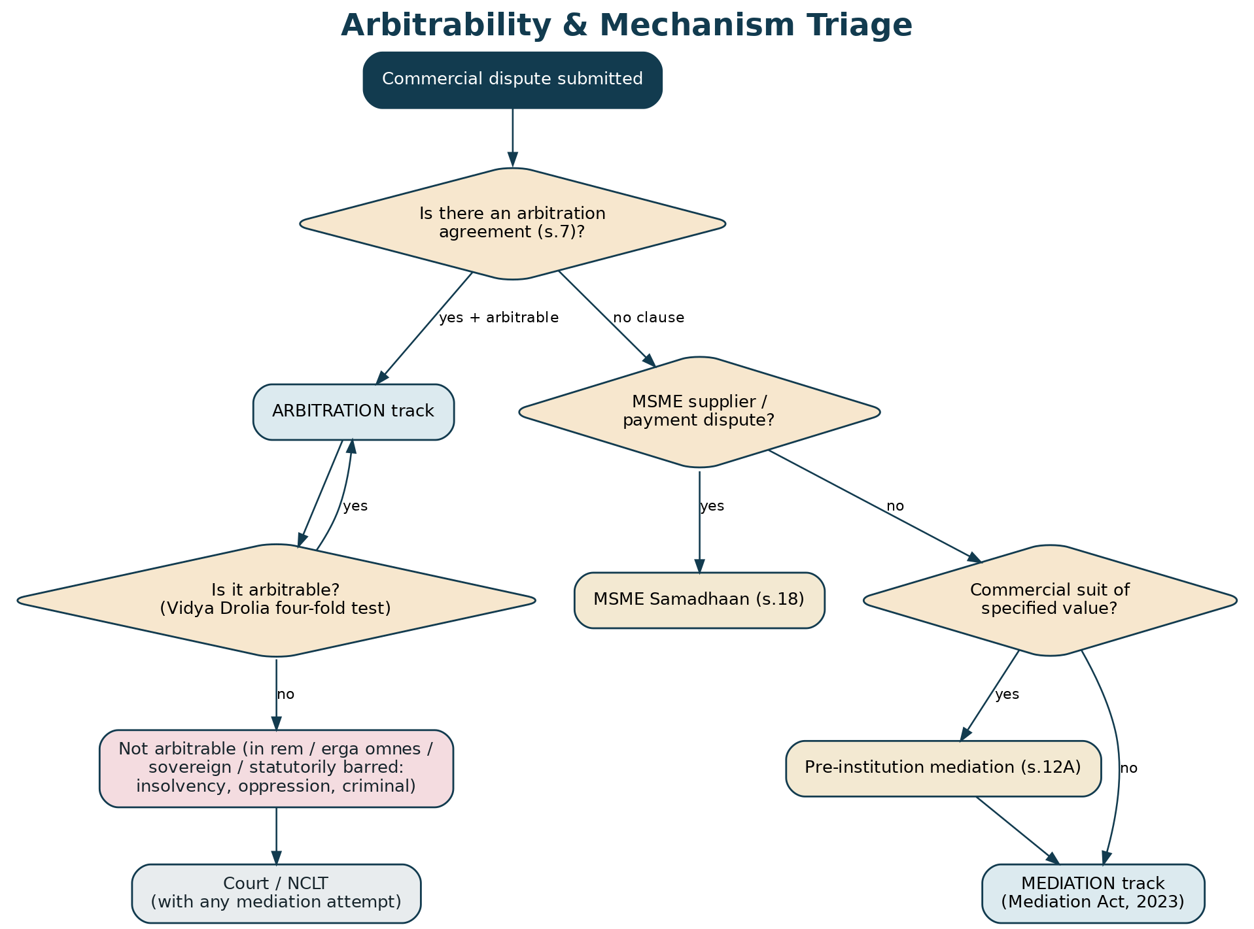
Figure 1 — Every commercial matter is triaged to the right mechanism: arbitration, MSME Samadhaan, or mediation.
3. Vision, Positioning & Guiding Principles
Equator's commercial vertical promises resolutions that are faster, more commercial and enforceable — an institution Indian businesses and their counsel trust to administer their most valuable disputes. Its principles: neutrality and independence of the institution and its neutrals; party autonomy over process and outcome; speed with due process; confidentiality; enforceability of every outcome; integrity (rigorous conflict management under the Act's Schedules); and data protection to the DPDP standard for commercially sensitive information.
4. How Equator Works as an Institution
Equator is the institution that administers the proceeding. For arbitration it maintains the panel, publishes the Rules of Arbitration and fee schedule, appoints or confirms the tribunal, provides the case-management platform and a tribunal secretary function, and holds the award repository. For mediation it acts as a Mediation Service Provider. For MSME matters it can administer the conciliation and arbitration a Facilitation Council refers. The neutral (arbitrator or mediator) decides or facilitates; the case manager drives the file and the clock; the parties and their counsel participate through secure logins. This institutional separation of roles is what the Arbitration Council of India will grade and what distinguishes Equator from ad-hoc arbitration.

PART B
The Legal Framework
5. Governing-Law Landscape: Which Mechanism Applies
PRACTICAL SUMMARY
Commercial disputes are resolved through several routes, and the first job of intake is to pick the right one: arbitration (if there's an arbitration clause and the matter is arbitrable), mediation (voluntary, or the mandatory Section 12A route before a commercial suit), or MSME Samadhaan (for small-supplier payment claims). Some matters — insolvency, company oppression, criminal — must go to a court or tribunal.

The mechanism is chosen from the nature of the dispute, the contract, and the parties. An arbitration agreement (Section 7 of the Arbitration & Conciliation Act) routes an arbitrable dispute to arbitration, and a court must refer the parties to arbitration under Section 8. Absent a clause, a commercial dispute of specified value must first attempt pre-institution mediation under Section 12A of the Commercial Courts Act. A micro or small enterprise chasing a delayed payment can invoke the MSME Samadhaan route. And some subject-matter is simply not arbitrable and belongs before a court or the NCLT. Equator's taxonomy captures these facts at intake and routes the matter automatically.
Route | When it applies | Governing law
Arbitration | Valid arbitration agreement + arbitrable subject-matter | Arbitration & Conciliation Act, 1996
Mediation (voluntary) | Parties choose to mediate | Mediation Act, 2023
Pre-institution mediation (s.12A) | Commercial suit of specified value, no urgent interim relief | Commercial Courts Act, 2015; Mediation Act, 2023
MSME Samadhaan | Micro/small supplier, delayed payment | MSMED Act, 2006 (ss.15–19)
Court / NCLT | Non-arbitrable (insolvency, oppression, etc.) | IBC 2016; Companies Act 2013; CPC

Table 1 — Mechanism selection for commercial disputes.
6. The Arbitration & Conciliation Act, 1996
PRACTICAL SUMMARY
The backbone of binding commercial dispute resolution. A written arbitration agreement sends the dispute to a private tribunal whose award is final and enforceable as a court decree. The Act sets tight timelines, limits court interference, and lets the tribunal grant interim relief. A draft 2024 Bill pushes hard toward institutional arbitration.

The Act (Part I) governs India-seated arbitration end to end. It begins with the arbitration agreement (Section 7) and the court's duty to refer parties to arbitration where one exists (Section 8), while preserving the court's power to grant interim measures (Section 9). The tribunal is constituted by the parties or, failing agreement, by appointment under Section 11 — which the 2019 amendments and the draft 2024 Bill would route through graded arbitral institutions rather than the courts. Every arbitrator must make disclosures and satisfy the independence and impartiality tests in Section 12, read with the Fifth and Seventh Schedules. The tribunal rules on its own jurisdiction (kompetenz-kompetenz, Section 16) and may grant interim measures itself (Section 17). The parties file their statements of claim and defence (Section 23, including any counterclaim), evidence and hearings follow (Section 24), and the tribunal makes a reasoned award (Section 31).
Two features make the Act commercially attractive: speed and finality. Section 29A requires the award within 12 months of completion of pleadings, extendable by 6 months by consent (and only thereafter by court), and Section 29B offers an even faster fast-track procedure. An award can be set aside only on the narrow grounds in Section 34 (within three months, plus a 30-day grace period), and once that window passes it is enforceable as a decree under Section 36. A settlement reached during arbitration is recorded as a consent award (Section 30). Foreign awards are enforced under Part II (the New York Convention, Sections 44–52).
LEGAL BASIS
Arbitration & Conciliation Act, 1996: s.7 (agreement), s.8 (reference), s.9 (court interim), s.11 (appointment), s.12 + Fifth/Seventh Schedules (disclosure, independence), s.16 (kompetenz-kompetenz), s.17 (tribunal interim), s.23 (pleadings/counterclaim), s.29A (12+6-month limit), s.29B (fast-track), s.30 (consent award), s.31 (award), s.34 (set aside), s.36 (enforcement), Part II ss.44–52 (foreign awards). Reform: draft Arbitration & Conciliation (Amendment) Bill, 2024 (institutional arbitration; s.9A emergency arbitration; s.34 partial set-aside; appellate arbitration; Arbitration Council of India).

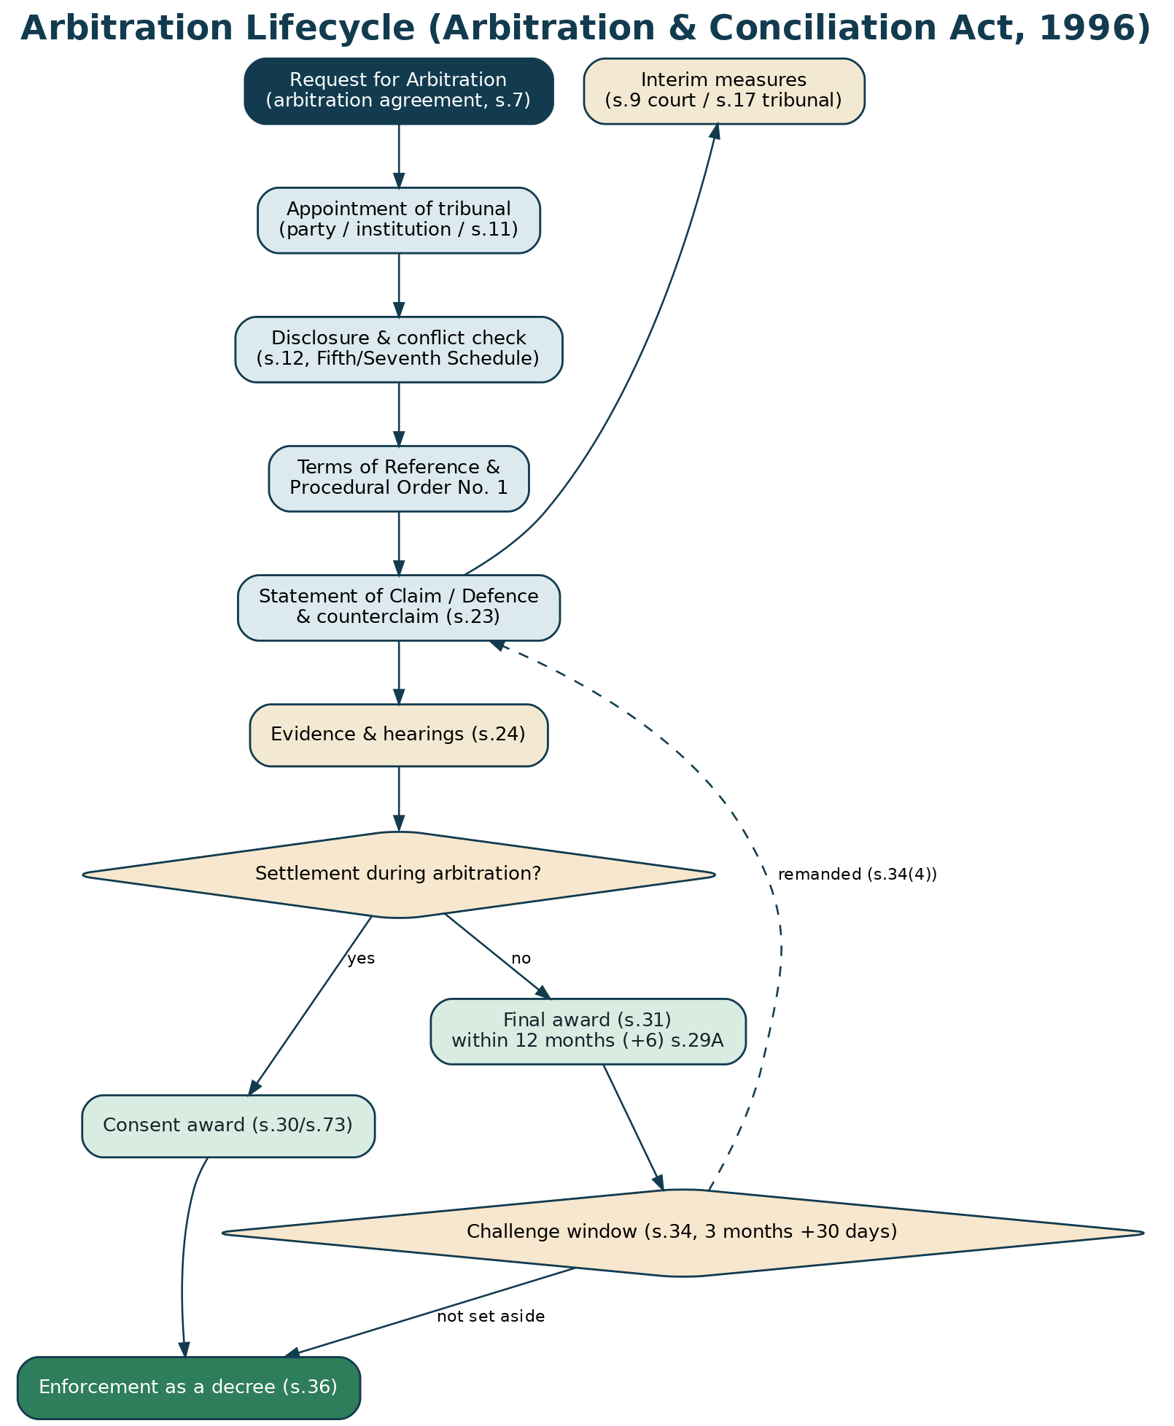
Figure 2 — The arbitration lifecycle, from request to enforcement, within the s.29A clock.
7. Mediation & Mandatory Pre-Institution Mediation (s.12A)
PRACTICAL SUMMARY
Mediation is the settlement route — voluntary, or mandatory before filing a commercial suit of specified value. Since the Supreme Court's Patil Automation ruling, a commercial plaint filed without first attempting Section 12A mediation can be rejected — unless it genuinely needs urgent interim relief. The settlement, once signed, is enforceable as a decree.

The Mediation Act, 2023 gives commercial mediation its general framework (see the family Blueprint for the Act's mechanics — 120+60-day clock, the Mediated Settlement Agreement, confidentiality, and enforceability as a decree under Section 27). Layered on top, Section 12A of the Commercial Courts Act, 2015 makes pre-institution mediation a mandatory gateway: a party cannot institute a commercial suit of specified value that does not contemplate urgent interim relief without first exhausting mediation, administered through the authorities notified for the purpose, to be completed within three months (extendable by two). The Supreme Court in Patil Automation held this requirement mandatory, so that a plaint filed in breach is liable to be rejected — a powerful driver of mediation demand that Equator is built to serve.
LEGAL BASIS
Mediation Act, 2023 (s.19 MSA, s.20 registration, s.22 confidentiality, s.27 enforceable as decree, s.28 challenge). Commercial Courts Act, 2015: s.12A (mandatory pre-institution mediation; specified value). M/s Patil Automation Pvt. Ltd. v. Rakheja Engineers Pvt. Ltd., (2022) 10 SCC 1 (s.12A is mandatory; prospective from 20 August 2022; urgent-interim-relief exception).

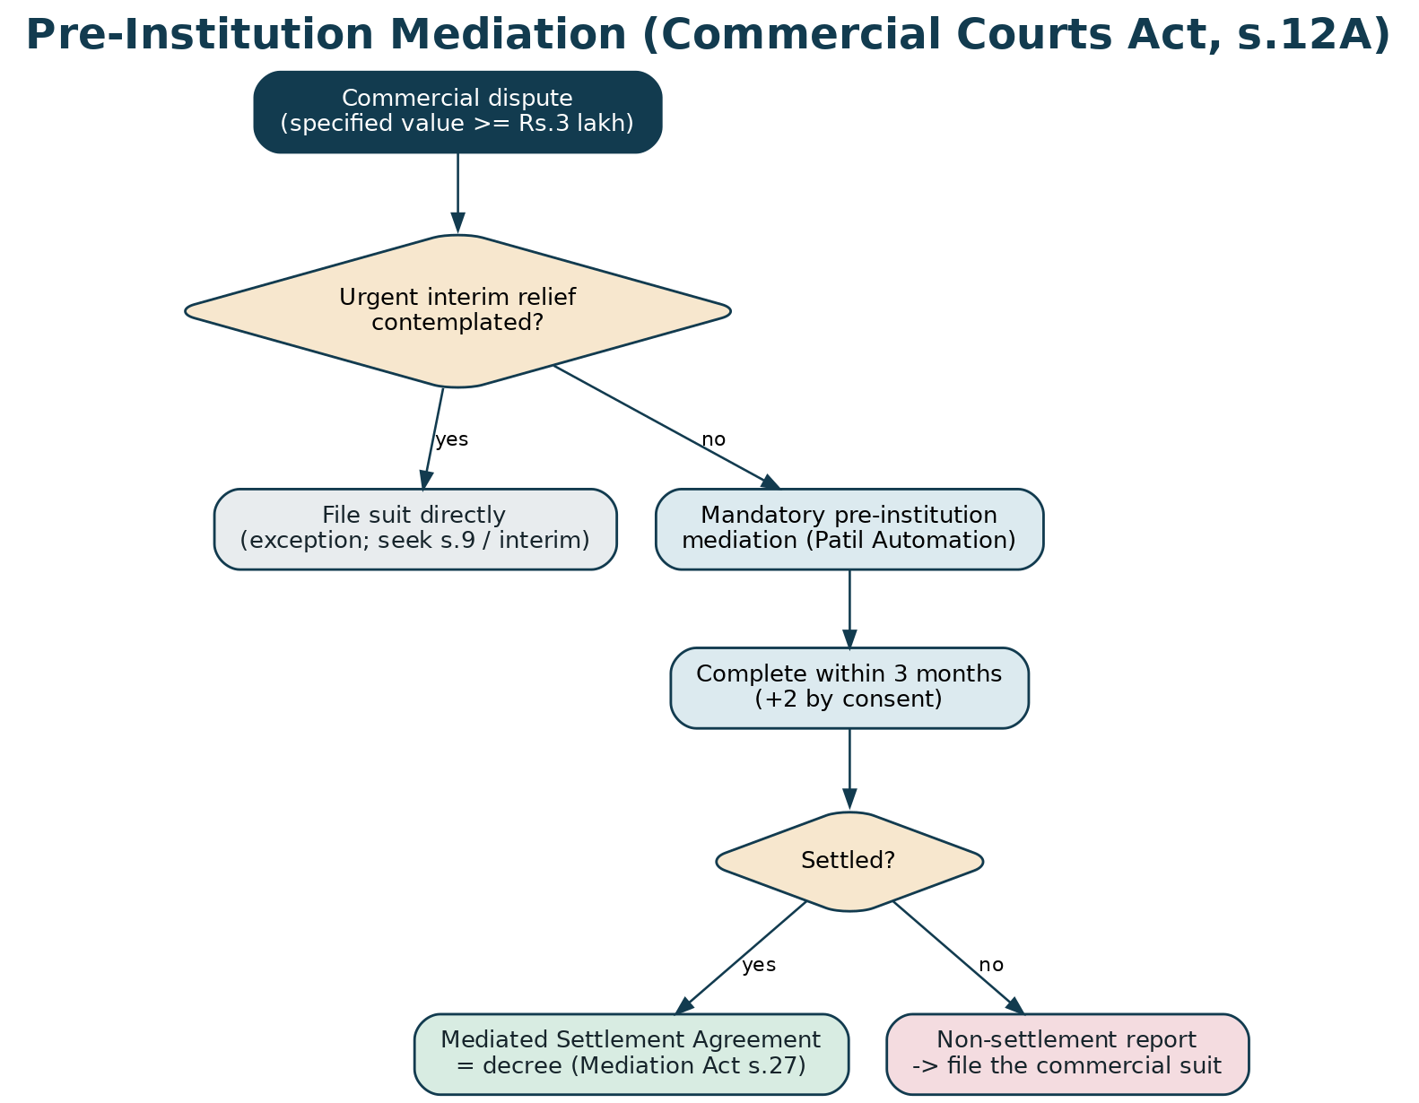
Figure 3 — The mandatory Section 12A pre-institution mediation gateway.
8. MSME Dispute Resolution (MSMED Act, 2006)
PRACTICAL SUMMARY
A statutory fast track for micro and small suppliers chasing delayed payments. If a buyer doesn't pay within 45 days, the supplier files on the MSME Samadhaan portal; the Facilitation Council first conciliates, and if that fails, arbitrates — with hefty statutory interest (three times the bank rate, compounded monthly) as leverage.

The MSMED Act, 2006 creates a powerful, supplier-friendly regime. A buyer must pay a micro or small enterprise within the agreed period or, failing agreement, within 45 days (Section 15); on default, the buyer is liable to compound interest at three times the RBI bank rate (Section 16). The supplier invokes the Micro and Small Enterprises Facilitation Council (MSEFC) under Section 18, in practice through the MSME Samadhaan online portal; the Council first attempts conciliation and, if that fails, takes up or refers the dispute to arbitration, to which the Arbitration & Conciliation Act applies, aiming to decide within 90 days. A buyer wishing to challenge an award must first deposit 75% of the amount (Section 19). Equator can serve this market both as a Council-referred institution and by helping suppliers prepare and file — with an interest calculator built in.
LEGAL BASIS
MSMED Act, 2006: s.15 (45-day payment), s.16 (interest at 3× bank rate, compounded monthly), s.17 (recovery), s.18 (MSEFC conciliation then arbitration; ~90 days), s.19 (75% pre-deposit to challenge). Delivered via the MSME Samadhaan portal. 2024 Supreme Court jurisprudence continues to refine the conciliation/arbitration interface.

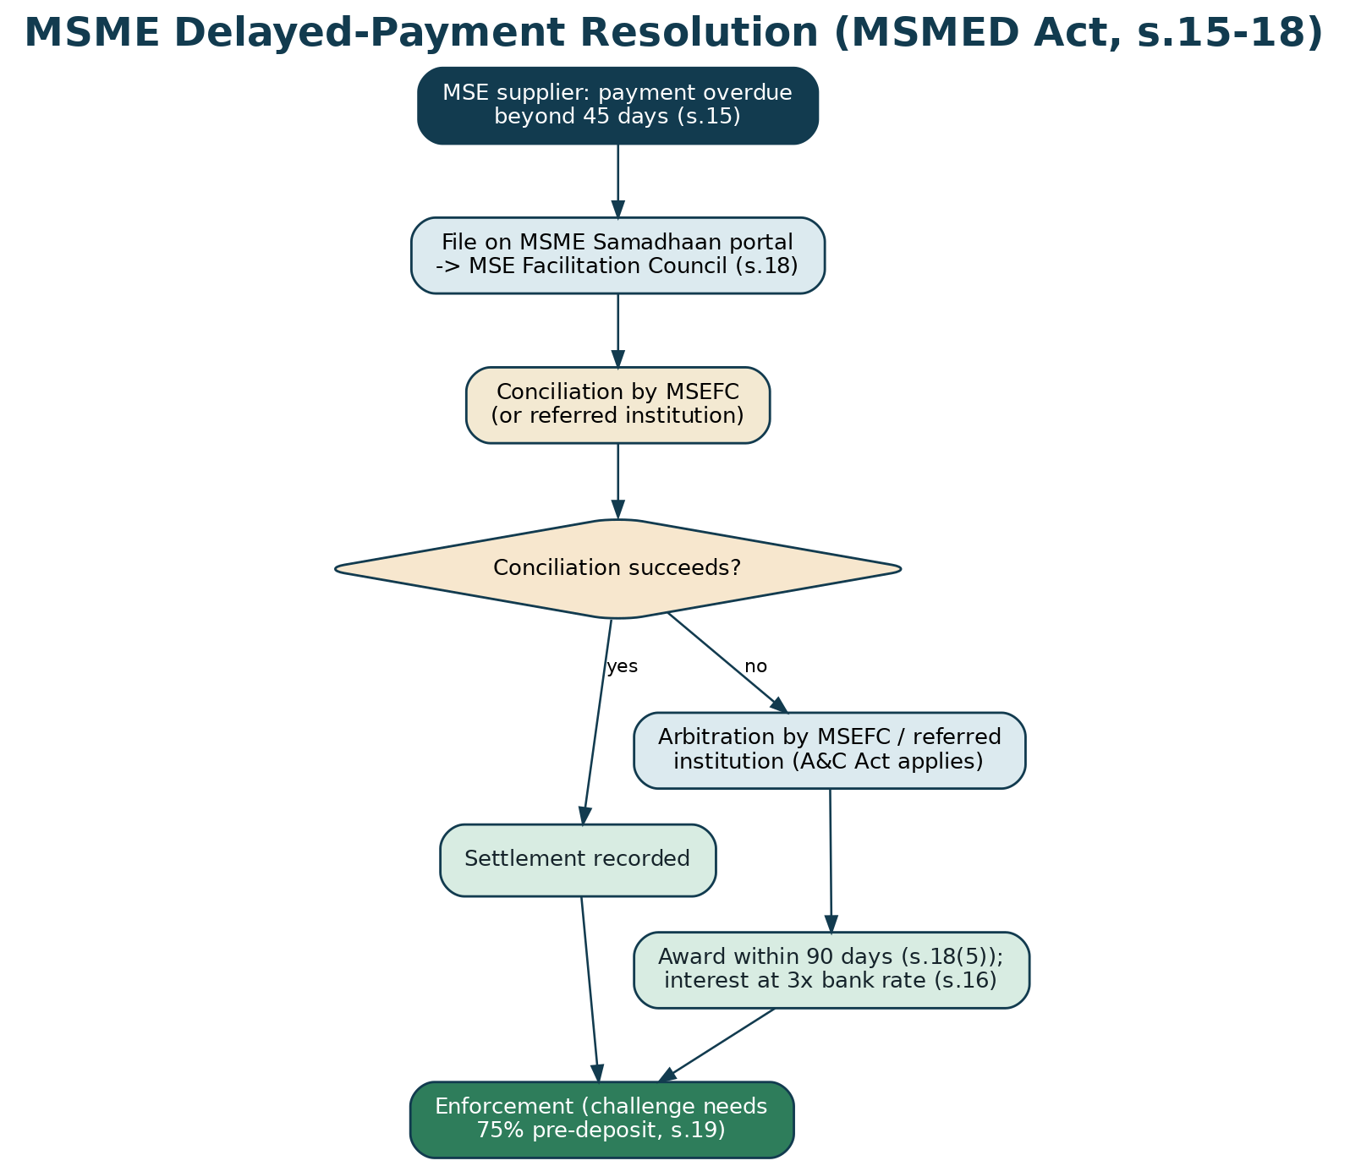
Figure 4 — The MSME delayed-payment route: Samadhaan → conciliation → arbitration.
9. Company & Shareholder Disputes
PRACTICAL SUMMARY
Fights between shareholders, partners, JV partners and within companies. Many are resolved by arbitration under the shareholders'/JV agreement — but oppression and mismanagement claims and insolvency are for the NCLT and are generally not arbitrable.

Company and shareholder disputes span a spectrum. Contractual disputes under shareholders' agreements, joint-venture and founders' agreements — on transfers, pre-emption, board rights, exit and valuation — are ordinarily arbitrable and are a core Equator arbitration segment. But claims of oppression and mismanagement under Sections 241–242 of the Companies Act, 2013 fall within the exclusive jurisdiction of the National Company Law Tribunal (NCLT), involve rights that affect the company and third parties, and are generally treated as non-arbitrable; likewise insolvency proceedings under the IBC, 2016. Equator's role is to arbitrate the contractual layer, mediate the relationship and commercial terms where possible, and route the statutory company-law remedies to the NCLT — while a mediated settlement can still resolve the underlying commercial reality behind an oppression petition.
LEGAL BASIS
Companies Act, 2013: ss.241–242 (oppression & mismanagement, NCLT), s.245 (class action). Insolvency & Bankruptcy Code, 2016. Arbitrability of company disputes assessed under Vidya Drolia (below); shareholder/JV contractual disputes are generally arbitrable, oppression/mismanagement and insolvency are not.

10. Contract & Transaction Disputes
The largest category by volume: disputes arising out of contracts and commercial transactions. These include breach of contract and damages, price and payment/recovery claims, supply, vendor and procurement disputes, distribution, franchise and agency disputes, construction and infrastructure claims, technology, IT and IP-licensing disputes, real-estate and lease disputes, banking, finance and guarantee disputes, partnership dissolutions, and post-M&A and indemnity claims. Substantively they are governed by the Indian Contract Act, 1872, the Sale of Goods Act, 1930, the Specific Relief Act, 1963 and the relevant sectoral law; procedurally, most are arbitrable and many carry an arbitration clause, while those without one and of specified value must pass through Section 12A mediation before court. Equator's taxonomy exposes each of these as selectable dispute types with the right mechanism attached.
LEGAL BASIS
Indian Contract Act, 1872; Sale of Goods Act, 1930; Specific Relief Act, 1963 (as amended 2018 — specific performance now the norm for contracts); sectoral statutes. Most contract/transaction disputes are arbitrable; enforcement of the resulting award under s.36.

11. Arbitrability — What Can and Cannot Be Arbitrated
PRACTICAL SUMMARY
Not every dispute can go to arbitration. The Supreme Court's four-fold test in Vidya Drolia keeps matters that affect the world at large, or that a statute reserves to a special forum, out of arbitration — for example insolvency, company oppression, and criminal matters.

Arbitrability is the gateway question for the arbitration track. In Vidya Drolia v. Durga Trading Corporation (2021), the Supreme Court laid down a four-fold test: a dispute is non-arbitrable when it (1) concerns rights in rem (rather than subordinate rights in personam flowing from them), (2) affects third-party rights or has erga omnes effect requiring centralised adjudication, (3) relates to inalienable sovereign or public-interest functions, or (4) is expressly or impliedly barred from arbitration by a statute. Applying this, disputes such as insolvency and winding-up, company oppression and mismanagement, criminal offences, matrimonial and guardianship matters, testamentary matters, and tenancy governed by special rent-control statutes are non-arbitrable; most contractual and commercial disputes — including, the Court confirmed, ordinary landlord–tenant disputes under the Transfer of Property Act — are arbitrable. Equator's intake runs this test as a triage so parties are not steered into a forum that cannot hear them.
LEGAL BASIS
Vidya Drolia v. Durga Trading Corporation, (2021) 2 SCC 1 (four-fold test for non-arbitrability; prima-facie review at the s.8/s.11 stage). Non-arbitrable illustrations: insolvency (IBC); oppression & mismanagement (Companies Act ss.241–242); criminal; testamentary; certain IPR-grant and statutory-tribunal matters.

12. Interim Measures & Emergency Arbitration
PRACTICAL SUMMARY
Sometimes a party needs urgent protection — to freeze an asset, preserve goods or stop a call on a guarantee — before or during arbitration. Courts (Section 9) and tribunals (Section 17) can grant it, and Indian law now recognises emergency arbitrator awards.

Urgent relief is available on both sides of the constitution of the tribunal. Before or during arbitration, a party may seek interim measures from the court under Section 9 (asset freezing, preservation of property, security), and once the tribunal is in place it may grant equivalent relief under Section 17, now enforceable as a court order. Institutional rules increasingly provide for an emergency arbitrator to grant relief before the main tribunal is constituted; the Supreme Court in Amazon.com NV Investment Holdings v. Future Retail (2021) recognised and enforced an emergency arbitrator's award in an India-seated arbitration, and the draft 2024 Bill proposes an express Section 9A for emergency arbitration. Equator's Rules will provide an emergency-arbitrator procedure and a fast interim-relief track.
LEGAL BASIS
Arbitration & Conciliation Act: s.9 (court interim measures), s.17 (tribunal interim measures, enforceable). Emergency arbitration: Amazon.com NV Investment Holdings LLC v. Future Retail Ltd., (2022) 1 SCC 209; proposed s.9A in the draft Amendment Bill, 2024.

13. Enforcement of Outcomes
PRACTICAL SUMMARY
An outcome only matters if it can be enforced. Domestic awards and mediated settlements are enforceable as court decrees; foreign awards are enforced under the New York Convention; and cross-border mediated settlements will benefit from the Singapore Convention once India ratifies it.

Equator's value rests on enforceable outcomes. A domestic award becomes enforceable as a decree under Section 36 once the Section 34 challenge window has passed (or a challenge has failed), and a challenge no longer automatically stays enforcement. A mediated settlement agreement is enforceable as a decree under Section 27 of the Mediation Act. A foreign award is enforced under Part II of the Arbitration Act, giving effect to the New York Convention (1958), subject to the limited refusal grounds in Section 48. For cross-border mediated settlements, the Singapore Convention on Mediation (2019) provides a New-York-Convention-style enforcement framework; India has signed but not yet ratified it, so Equator flags this as a watch item for international matters. The platform's escrow and e-execution features make voluntary compliance the norm and enforcement the exception.
LEGAL BASIS
Domestic award: s.36 (enforcement as a decree). Foreign award: Part II, ss.44–52 (New York Convention); refusal grounds s.48. Mediated settlement: Mediation Act s.27. Cross-border mediation: Singapore Convention on Mediation, 2019 — signed by India (7 Aug 2019), not yet ratified as of 2026.

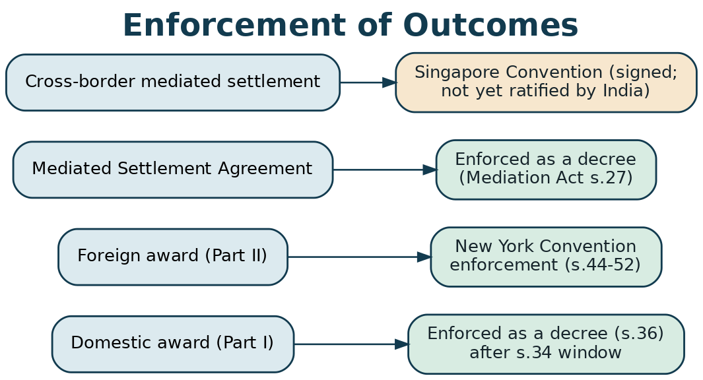
Figure 5 — Enforcement pathways for awards and settlements, domestic and cross-border.

PART C
The Platform & Procedure
14. Dispute Taxonomy & Dropdown Architecture
PRACTICAL SUMMARY
The menu the website shows a business: Dispute type → sub-issue → mechanism → sector, plus claim value, governing law, seat and language. Selecting them attaches the right law, mechanism, forms and neutral filters. The machine-readable version is in the Developer Workbook.

A user identifies the dispute type, one or more specific issues, the sector, the claim value band, whether an arbitration agreement exists, and preferences for seat, governing law and language. The platform uses these to select the mechanism (arbitration / mediation / s.12A / MSME), attach the applicable-law checklist and forms, run the arbitrability triage, and filter the neutral panel by sector expertise.
Dispute type | Representative issues | Usual mechanism
Breach of contract / damages | Non-performance, defective performance, repudiation, damages | Arbitration (if clause) / s.12A mediation
Payment & recovery | Unpaid invoices, price disputes, retention | Arbitration / MSME (if MSE) / s.12A
Supply, vendor & procurement | Delivery, quality, warranty, termination | Arbitration / mediation
Distribution, franchise & agency | Territory, termination, commissions | Arbitration / mediation
Shareholder / JV / partnership | SHA/JV breaches, transfers, exit, valuation, dissolution | Arbitration (contractual) / mediation
Company oppression & mismanagement | Minority rights, board control | NCLT (non-arbitrable); mediate commercial layer
Construction & infrastructure | Delay, variations, certification, EPC claims | Arbitration / dispute board
Technology, IT & IP | SaaS/licensing, SLAs, IP use (not grant) | Arbitration / mediation
Real estate & lease | Sale, lease, development, RERA interface | Arbitration / mediation / court
Banking, finance & guarantee | Facility, guarantee, recovery, LC disputes | Arbitration / DRT interface
MSME delayed payment | Overdue payment to a micro/small supplier | MSME Samadhaan (s.18)
Cross-border / international | Foreign party, foreign seat, enforcement | Institutional arbitration / mediation

Table 2 — Commercial dispute-type → issues → mechanism map (full schema in the Developer Workbook).
14.1 Key dropdowns & options
Beyond dispute type, the intake exposes: mechanism (arbitration / mediation / s.12A pre-institution / MSME Samadhaan / expert determination); sector (manufacturing, IT/tech, construction/infra, BFSI, real estate, pharma, retail/FMCG, energy, logistics, services, etc.); claim-value band (drives the fee tier and whether a sole or three-member tribunal is apt); number of arbitrators (sole / three); seat and venue; governing law; language; institutional rules (Equator Rules by default); urgency (emergency/interim relief needed); and relief sought (damages, specific performance, debt + interest, injunction, declaration, account, termination, etc.).
15. User Roles & Access Management
Role | Who | Core permissions
Claimant | Party commencing (any business/individual) | File request; upload contract & evidence; nominate arbitrator; join hearings; e-sign; fund/receive escrow
Respondent | The other party | Respond; counterclaim; nominate arbitrator; upload evidence; join; e-sign; escrow
Arbitrator / Tribunal | Empanelled, conflict-checked neutral(s) | View filings & evidence; conduct hearings; issue orders & award; cannot alter fees/escrow
Mediator | Empanelled neutral | Conduct sessions; draft MSA; issue reports
Case Manager / Tribunal Secretary | Equator officer | Screen; appoint; enforce timeline; schedule; manage documents, escrow & repository; support tribunal (no decision role)
Counsel / Representative | For either party | Represent, file and argue on authorisation; attend hearings
Administrator | Equator admin | Panel & grading; audit logs; compliance & DPDP; no access to deliberations
Escrow Officer | Equator finance + partner bank | Set up escrow; verify funding; conditional release; KYC/PMLA

Table 3 — Roles and least-privilege access (arbitration & mediation).
16. Onboarding & Registration (KYC / KYB)
PRACTICAL SUMMARY
Businesses verify who they are (KYB — know your business), the platform captures the contract and the arbitration clause, DPDP consent is recorded, and the matter is triaged to the right mechanism.

- Dispute Explorer (no login): AI-assisted self-assessment — mechanism, arbitrability and likely remedies.
- Account & KYB: entity verification (CIN/GSTIN/PAN, authorised-signatory proof, board resolution/authority), plus individual KYC for signatories.
- DPDP consent: itemised notice and consent for processing commercially sensitive data; confidentiality undertakings.
- Dispute intake: dispute type → issues → sector → claim value → arbitration clause? → seat/law/language; upload the contract, the clause and key evidence.
- Mechanism triage & agreement to the Rules: the platform runs the arbitrability/mechanism triage; parties accept the applicable Rules and fee schedule and e-sign.
- Screening & registration: the case manager validates, assigns a case number, and opens the file.

17. End-to-End Workflow (Dual-Track)
Commercial matters run on one of three tracks — arbitration, mediation (incl. s.12A) or MSME Samadhaan — sharing common intake, escrow, e-execution and enforcement. The arbitration track proceeds from request to appointment, Terms of Reference and Procedural Order No. 1, pleadings and counterclaim, interim relief where needed, evidence and hearings, and a reasoned award within the Section 29A clock, followed by the challenge window and enforcement. The mediation track proceeds from request/notice to mediator appointment, sessions, and a Mediated Settlement Agreement. A matter can also move between tracks — a common and powerful pattern is med-arb: attempt mediation, and if it fails, proceed to a binding award.
Figure 6 — Arbitration track lifecycle (see Figures 3–4 for the mediation and MSME tracks).
18. Initiation, Response & Counterclaim
Either party may commence. In arbitration, the Claimant files a Request for Arbitration invoking the arbitration agreement; the Respondent files a Response and may bring a counterclaim (Section 23). In mediation, either party files a Request and the other is invited to participate (for the mandatory s.12A route, the applicant initiates pre-institution mediation before any suit). The platform is symmetrical and captures the whole dispute — claims and counterclaims — so the proceeding resolves the entire commercial relationship, not one side's grievance.
19. Neutral Selection & Empanelment
PRACTICAL SUMMARY
Parties choose a sole arbitrator or a three-member tribunal (or a mediator), filtered by sector expertise, seniority, seat, language and fee. Every neutral clears the Act's disclosure and independence tests before appointment.

Equator maintains a graded panel of arbitrators (former judges, senior advocates, and sector experts) and mediators, filterable by sector specialisation, seniority/grade, seat, language, availability and fee. Appointment follows party autonomy: the parties may jointly name a sole arbitrator, each nominate a co-arbitrator (who then appoint the presiding arbitrator) for a three-member tribunal, or ask Equator to appoint institutionally (the model the 2024 Bill promotes, and the default where parties do not agree or where a court would otherwise appoint under Section 11). Every candidate makes the Section 12 disclosures and is cleared against the Fifth and Seventh Schedules before the appointment is confirmed.
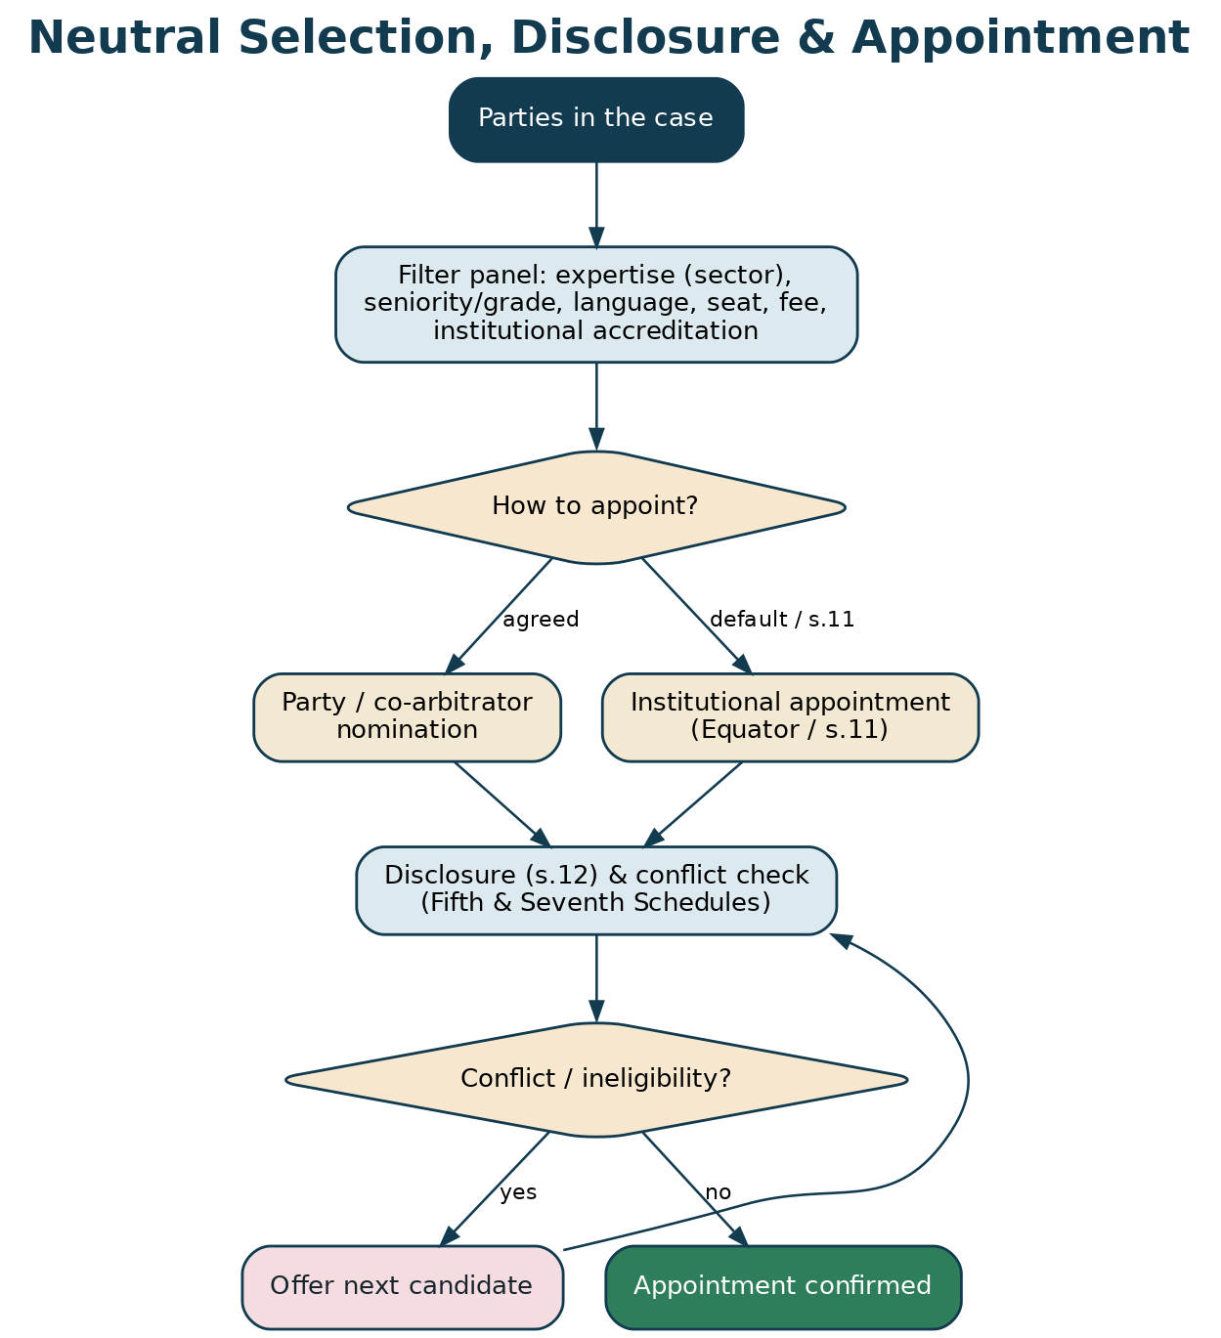
Figure 7 — Neutral selection, disclosure (s.12) and appointment.
19.1 Empanelment standard
Empanelment requires demonstrated arbitration/mediation experience or accredited training, sector credentials, a clean conflicts declaration, acceptance of the Equator Code of Conduct and — as the Arbitration Council of India grading framework matures — institutional accreditation. Panellists are graded for fee and seniority, sector-tagged, and continuously evaluated through party feedback and award quality, with de-empanelment for breaches of independence or confidentiality.
20. Conducting Proceedings — Case Manager & Tribunal Secretary Playbook
The case manager is the institution's engine and, in arbitration, provides a tribunal-secretary function — strictly administrative, never decisional. The rhythm: validate and register; serve notices and constitute the tribunal (disclosure and conflict checks); convene the first procedural hearing and settle Terms of Reference and Procedural Order No. 1 (timetable, seat, language, document protocol); manage the exchange of pleadings, counterclaim and evidence; schedule and support hearings (in person, video or hybrid); track the Section 29A clock and any extension; support the tribunal in issuing interim orders and the award (formatting, not content); set up escrow and the enforcement/registration steps; and maintain the award/MSA repository and audit trail.
Stage | Case-manager / secretary actions | Key forms / outputs
Intake & screening | KYB/KYC & consent; arbitrability/mechanism triage; register | Screening checklist; case record
Constitution | Serve notice; run nominations/appointment; disclosure & conflict check | F-C05 Nomination; F-C06 Disclosure
Case setup | First procedural hearing; ToR & PO-1; timetable | F-C07 ToR; F-C08 PO-1
Pleadings | Manage Statement of Claim, Defence & counterclaim, evidence | F-C09 SoC; F-C10 SoD/Counterclaim
Interim | Coordinate s.9/s.17 / emergency-arbitrator relief | F-C11 Interim application
Hearings | Convene & log hearings; manage the s.29A clock; extensions | Hearing log; F-C13 time extension
Award / settlement | Support award issuance / draft MSA / consent award; escrow | F-C12 Award/MSA; F-C15 Escrow
Closure | Enforcement/registration; repository; closure report | F-C16 Enforcement checklist; F-C17 Closure

Table 4 — Case-manager / tribunal-secretary operating rhythm.
RISK / CAUTION
The tribunal secretary must never influence the tribunal's decision or draft its reasoning — excessive delegation is a ground to challenge an award. The role is scheduling, documents, logistics and formatting only.

21. Time-Bound Procedure & Service Levels
Milestone | Target | Basis
Case registration after complete filing | 1–2 working days | Equator SLA
Notice / constitution of tribunal | ≤ 30 days | Equator SLA / party agreement
First procedural hearing, ToR & PO-1 | ≤ 21 days of constitution | Equator SLA
Completion of pleadings | Per PO-1 timetable | s.23 / PO-1
Arbitral award | Within 12 months of completion of pleadings | s.29A
Extension by consent | Up to a further 6 months | s.29A
Fast-track award | Within 6 months | s.29B
Pre-institution mediation (s.12A) | 3 months (+2 by consent) | Commercial Courts Act s.12A
MSME Samadhaan | ~90 days | MSMED Act s.18(5)
Challenge to award | 3 months (+30 days) | s.34

Table 5 — Statutory limits and Equator service levels.
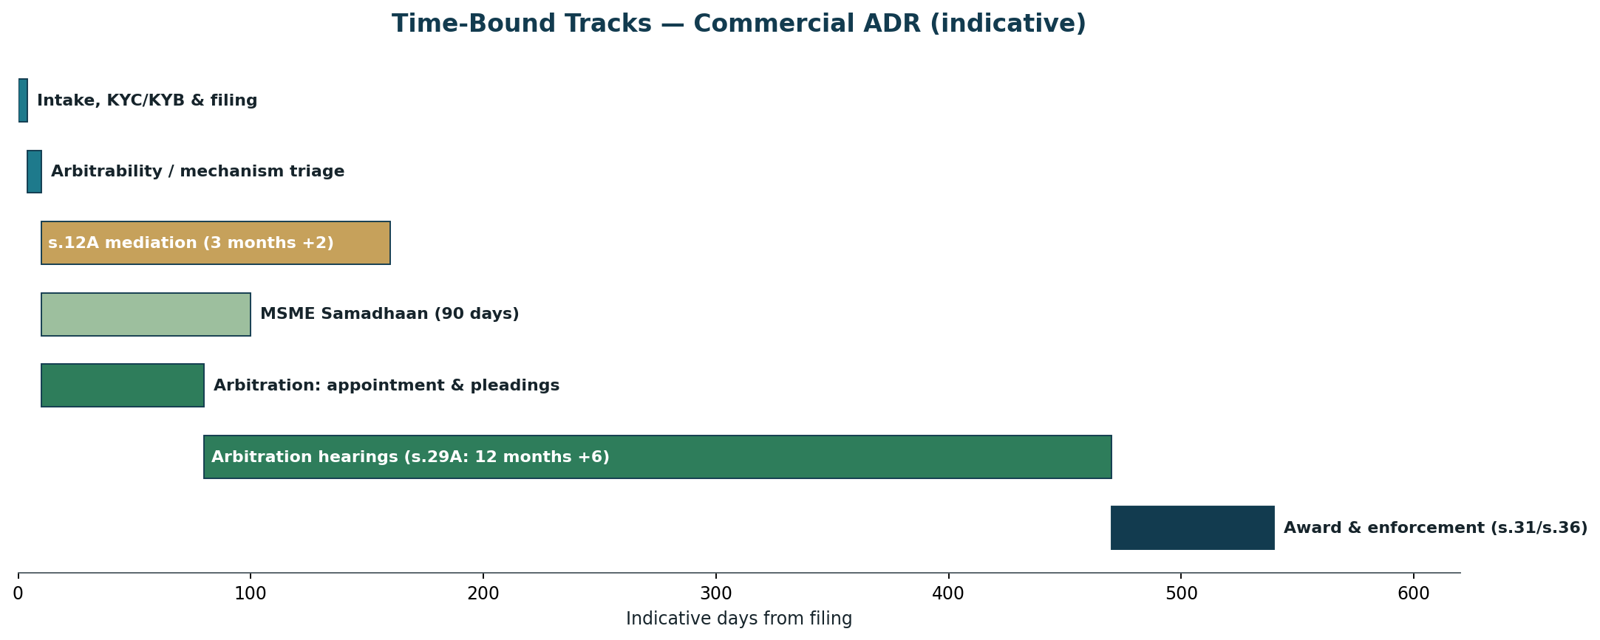
Figure 8 — Indicative time-bound tracks across arbitration, s.12A mediation and MSME.
22. Award, Settlement & Consent Award
An arbitration ends in a reasoned award (Section 31) — final, binding and enforceable as a decree. Where the parties settle during arbitration, the tribunal records the settlement as a consent award (Section 30), which has the same status and enforceability as any other award — often the fastest, cleanest exit. A mediation ends in a Mediated Settlement Agreement (enforceable as a decree under Section 27). Equator drafts to be enforcement-ready: clear operative directions, interest, costs, and e-execution.
23. Enforcement Support
Equator supports the winning party to realise the outcome: guidance and templates for enforcement of a domestic award as a decree (Section 36), for foreign-award enforcement under the New York Convention (Part II), and for enforcing a mediated settlement (Section 27); coordination of e-stamping and registration; and escrow release on compliance. The platform tracks the Section 34 challenge window and flags any stay, and — for cross-border settlements — notes the Singapore Convention position.
24. The Escrow Mechanism
PRACTICAL SUMMARY
A neutral holding account for award and settlement money. The payer deposits; the escrow agent (a regulated bank) releases to the payee against defined conditions — so payment is secure and disputes about payment don't reopen the fight.

Commercial outcomes frequently involve substantial sums, staged payments and performance conditions. Equator arranges a tripartite escrow with a regulated bank as escrow agent, grounded in the Indian Contract Act (agency and bailment) and KYC/PMLA-compliant. The payer deposits the award/settlement sum (or instalments); release is conditional and staged against milestones written into the award or MSA — for example, on lapse of the Section 34 window without a stay, on delivery/handover, or on completion of an agreed performance step — each receipted and audit-logged, with a defined fallback if a milestone is missed.
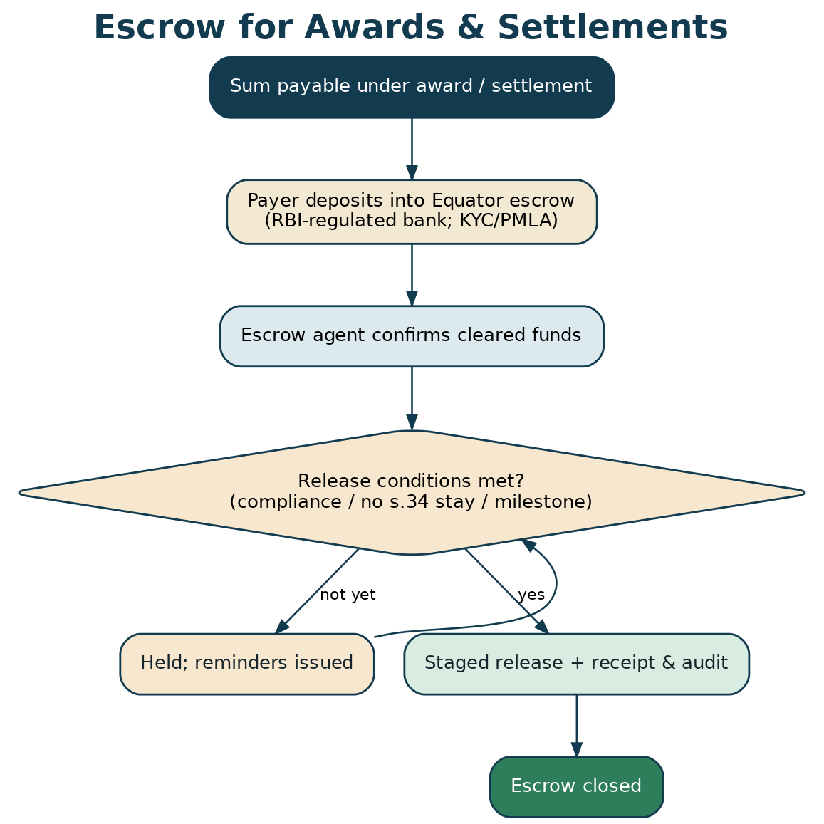
Figure 9 — Escrow for award and settlement sums, released against compliance.
25. Permutations & Scenarios — the If / Then Logic
If this circumstance… | …then Equator does this
There is a valid arbitration clause | Route to arbitration; constitute the tribunal; run disclosure/conflict checks.
No clause, commercial suit of specified value | Route to mandatory s.12A pre-institution mediation before any suit.
A micro/small supplier chasing payment | Route to MSME Samadhaan (conciliation then arbitration); compute s.16 interest.
Subject-matter is non-arbitrable (insolvency, oppression) | Do not arbitrate; mediate the commercial layer where possible; route statutory remedy to NCLT/court.
Urgent relief needed before the tribunal exists | Offer emergency-arbitrator relief and/or a s.9 court application; expedite.
Mediation fails | Proceed to arbitration (med-arb) or issue a non-settlement/s.12A report enabling suit.
Party won't participate / no response | Proceed per the Rules (default participation) or issue the appropriate report; preserve remedies.
Foreign party / foreign seat | Apply institutional international rules; plan New York Convention enforcement; video hearings.
Settlement reached mid-arbitration | Record a consent award (s.30) — fastest enforceable exit.
Award challenged (s.34) | Track the challenge; hold escrow; no automatic stay of enforcement.
Multi-contract / multi-party dispute | Consolidation / joinder per the Rules; single case management.
Confidential / trade-secret evidence | Confidentiality ring; restricted access; protective order.

Table 6 — Principal branch conditions and Equator's programmed response.

PART D
Governance, Commercials & Operations
26. Forms Register
All commercial forms are reproduced in full in Part H and delivered as individual documents in the archived Forms Pack folder. The Developer Workbook carries the field-level schema for each.
Ref | Form | Used at
F-C01 | Onboarding, KYB/KYC & DPDP Consent | Registration
F-C02 | Request for Arbitration | Commencement (arbitration)
F-C03 | Response to Request for Arbitration (+ counterclaim) | Response
F-C04 | Request for Mediation / s.12A Pre-Institution Mediation Application | Commencement (mediation)
F-C05 | Nomination & Appointment of Arbitrator | Constitution
F-C06 | Arbitrator's Disclosure & Statement of Independence (s.12) | Constitution
F-C07 | Terms of Reference | Case setup
F-C08 | Procedural Order No. 1 | Case setup
F-C09 | Statement of Claim | Pleadings
F-C10 | Statement of Defence & Counterclaim | Pleadings
F-C11 | Application for Interim Measures (s.9 / s.17 / emergency) | Interim
F-C12 | Consent Award / Mediated Settlement Agreement | Settlement
F-C13 | Application for Time Extension (s.29A) | Sessions/hearings
F-C14 | MSME Samadhaan Reference | MSME route
F-C15 | Escrow Instruction & Release Schedule | Settlement/award
F-C16 | Enforcement Checklist (s.36 / Part II) | Closure
F-C17 | Case Closure / Award Transmittal | Closure
F-C18 | Agreement to Mediate & Confidentiality (commercial) | Pre-mediation
F-C19 | Costs & Fee Statement | Billing
F-C20 | Model Arbitration & ADR Clause (for contracts) | Clause insertion

Table 7 — Commercial forms register (full text in Part H; schema in the Developer Workbook).
27. Fees & Commercials
Commercial ADR fees are typically ad valorem — scaled to the amount in dispute — plus a registration/administration fee and the neutral's fee (which for arbitration may follow the Fourth Schedule to the Arbitration Act or the institution's schedule). Equator publishes a transparent tariff with bands by claim value, sole vs three-member tribunal, fast-track discounts, and an escrow-handling fee. A claim-value fee calculator (companion tool) gives parties an instant estimate.
Component | Basis | Indicative
Registration / filing fee | One-time, per case | Flat by band
Administration fee | % of claim value (ad valorem), banded | Per tariff
Arbitrator fee | Per Fourth Schedule / institutional schedule; sole vs panel | Ad valorem
Mediator fee | Per session / by grade | Per schedule
Emergency-arbitrator fee | Fixed, expedited | Per schedule
Escrow handling | % of amount held / flat | Per bank tariff
Fast-track discount | Reduced where s.29B / expedited chosen | Per tariff

Table 8 — Fee architecture (confirm against Equator's published tariff and the Fourth Schedule).
28. Risk, Ethics & Compliance Register
Risk | Impact | Mitigation
Arbitrator bias / non-disclosure | Award set aside (s.34); reputational | Rigorous s.12 disclosure; Fifth/Seventh Schedule checks; conflict tooling
Excessive tribunal-secretary delegation | Challenge to award | Secretary strictly administrative; tribunal decides & drafts
Arbitrating a non-arbitrable dispute | Void proceedings | Vidya Drolia triage at intake; route to NCLT/court
Missing s.12A / MSME steps | Plaint rejected / jurisdiction lost | Mechanism triage; certificates; workflow gates
Breach of confidentiality | Loss of trust; commercial harm | Confidentiality rings; RBAC; NDAs; audit logs
Data breach (commercial data) | DPDP penalties; harm | Encryption, access control, breach protocol, minimisation
Escrow funds mishandled | Financial loss; disputes | Regulated agent; KYC/PMLA; conditional release; audit
AI error / disguised advice | Harm; UPL exposure | Guardrails; human-in-the-loop; information not advice

Table 9 — Principal risks and controls.
29. Implementation Roadmap
- Phase 1 (Months 1–3): publish Rules of Arbitration, Mediation Rules & fee schedule; stand up intake, triage, KYB and case management; empanel the first arbitrator & mediator cohort with conflict tooling; deploy the Forms Pack.
- Phase 2 (Months 3–5): escrow integration; emergency-arbitrator & interim-relief track; MSME Samadhaan workflow; e-Sign/e-Stamp; supervised pilot cases.
- Phase 3 (Months 5–8): court/tribunal referral (s.12A authorities, s.11/s.8) alignment; Arbitration Council of India grading readiness; institutional-partner clause-insertion programme (loans, MSAs, procurement).
- Phase 4 (Months 8–12): scale the panel and sectors; international/cross-border arbitration; publish anonymised outcome data and a rules commentary.

30. Key Performance Indicators
KPI | Definition | Target (Year 1)
Time to constitution | Filing → tribunal constituted | ≤ 30 days (median)
Cycle time (arbitration) | Pleadings complete → award | ≤ 12 months
Cycle time (mediation/s.12A) | Filing → MSA / report | ≤ 90 days
Settlement rate (mediation) | Settled ÷ commenced | ≥ 50%
Award challenge rate (s.34) | Awards challenged ÷ rendered | ≤ 10%
Set-aside rate | Awards set aside ÷ challenged | ≤ 15%
Enforcement success | Awards/MSAs enforced or complied | ≥ 90%
Escrow reliability | Releases executed to schedule | ≥ 99%
Time-limit compliance | Awards within s.29A | 100%
Party satisfaction | Post-case CSAT | ≥ 4.3 / 5

Table 10 — Commercial-vertical KPIs.

PART E
Strengthening Resolution & Global Best Practice
31. Global Best Practice in Commercial ADR
PRACTICAL SUMMARY
The world's leading arbitral institutions — SIAC, ICC, LCIA, HKIAC, SCC and the AAA/ICDR — have proven what makes institutional arbitration work: strong rules, credible panels, expedited and emergency procedures, and light-touch but effective administration. Equator adopts these, adapted to Indian law.

Equator's Rules and practice draw on the global consensus. From the UNCITRAL Model Law and Arbitration Rules — on which India's Act is based — come the core architecture and party autonomy. From SIAC, ICC, LCIA, HKIAC and SCC come the features that make modern institutional arbitration fast and trusted: an expedited procedure for lower-value or urgent matters; an emergency arbitrator for pre-tribunal relief; consolidation and joinder for multi-contract and multi-party disputes; scrutiny of draft awards for quality; transparent, ad valorem fee schedules; and a professional case-management secretariat. From the ICC and construction practice come tiered (med-arb) clauses and dispute boards. Equator localises all of this within the Arbitration & Conciliation Act and the Mediation Act.
Institution / instrument | Signature practice | What Equator adopts
UNCITRAL Model Law & Rules | The global template India's Act follows | Model-Law-aligned Rules; party autonomy; kompetenz-kompetenz
SIAC / ICC / LCIA / HKIAC | Expedited procedure; emergency arbitrator; scrutiny of awards | Expedited & emergency tracks; award scrutiny for quality
ICC / construction practice | Tiered med-arb clauses; dispute boards | Model tiered clauses; dispute-board option
AAA/ICDR | Strong ODR & case-management technology | ODR-native platform; AI-assisted administration
Singapore Convention | Cross-border enforceability of mediated settlements | International mediation ready (watch India ratification)

Table 11 — Global best practice mapped to Equator's Indian implementation.
32. Institutional Excellence & Getting Parties to the Table
Institutional credibility drives adoption. Equator earns it through published, predictable Rules; a graded, transparent panel with real sector depth; speed (expedited and fast-track options, a disciplined s.29A clock); and clause insertion — embedding the Equator arbitration/ADR clause into loan agreements, MSAs, procurement contracts, shareholder and JV agreements and terms of service, so that future disputes arrive pre-committed to Equator. The mandatory s.12A gateway and court referrals (ss.8, 11, 89 CPC) supply a further, compelled pipeline.
33. Better Outcomes — Beyond Binary Win/Lose
- Tiered (med-arb) clauses: Negotiate → mediate → arbitrate: resolve early where possible, guarantee finality where not.
- Early Neutral Evaluation: A senior neutral gives a non-binding, candid assessment that realigns expectations and settles cases.
- Expert determination: For technical/valuation disputes (accounts, engineering, IP royalties), a binding expert decision — fast and cheap.
- Dispute boards: Standing boards for long construction/infrastructure projects to resolve issues in real time.
- Expedited & documents-only: For lower-value or straightforward matters — an award on documents, no oral hearing.
- Consolidation & joinder: One proceeding for related multi-contract, multi-party disputes — efficiency and consistency.

34. Measuring Resolution Quality & Continuous Improvement
Beyond throughput, Equator measures what makes an institution trusted: enforceability (low set-aside rate), speed (s.29A compliance, time-to-award), durability (compliance/enforcement rate), quality (award scrutiny outcomes, party satisfaction), and integrity (disclosure completeness, conflict incidents). An anonymised awards and clause bank and a published rules commentary build jurisprudential authority over time.

PART F
Technology — AI, ODR, e-Sign, e-Stamp & Court Integration
35. The AI-Assisted Commercial Dispute Explorer
PRACTICAL SUMMARY
The AI front door for businesses: it answers questions about Equator's process and about the remedies for their dispute, checks which mechanism fits and whether the matter is arbitrable, and drafts the Request for Arbitration or Statement of Claim — always as a reviewable draft, not legal advice.

The AI assistant is grounded (retrieval-augmented) on Equator's Rules and the commercial legal framework in this Blueprint. For a business user it provides: procedure Q&A; a mechanism recommender (arbitration vs mediation vs s.12A vs MSME vs court), reasoned from the dispute, the contract and the arbitrability triage; remedies and interest guidance (including MSME Section 16 interest); and drafting help for the Request for Arbitration, Statement of Claim, or Response/Counterclaim from the user's facts and contract. For the case manager and tribunal it drafts procedural orders, timelines and correspondence, runs first-pass conflict checks, summarises evidence, and proposes award formatting — always under human control. It informs, it does not advise, and it defers to a human whenever the matter needs judgement.
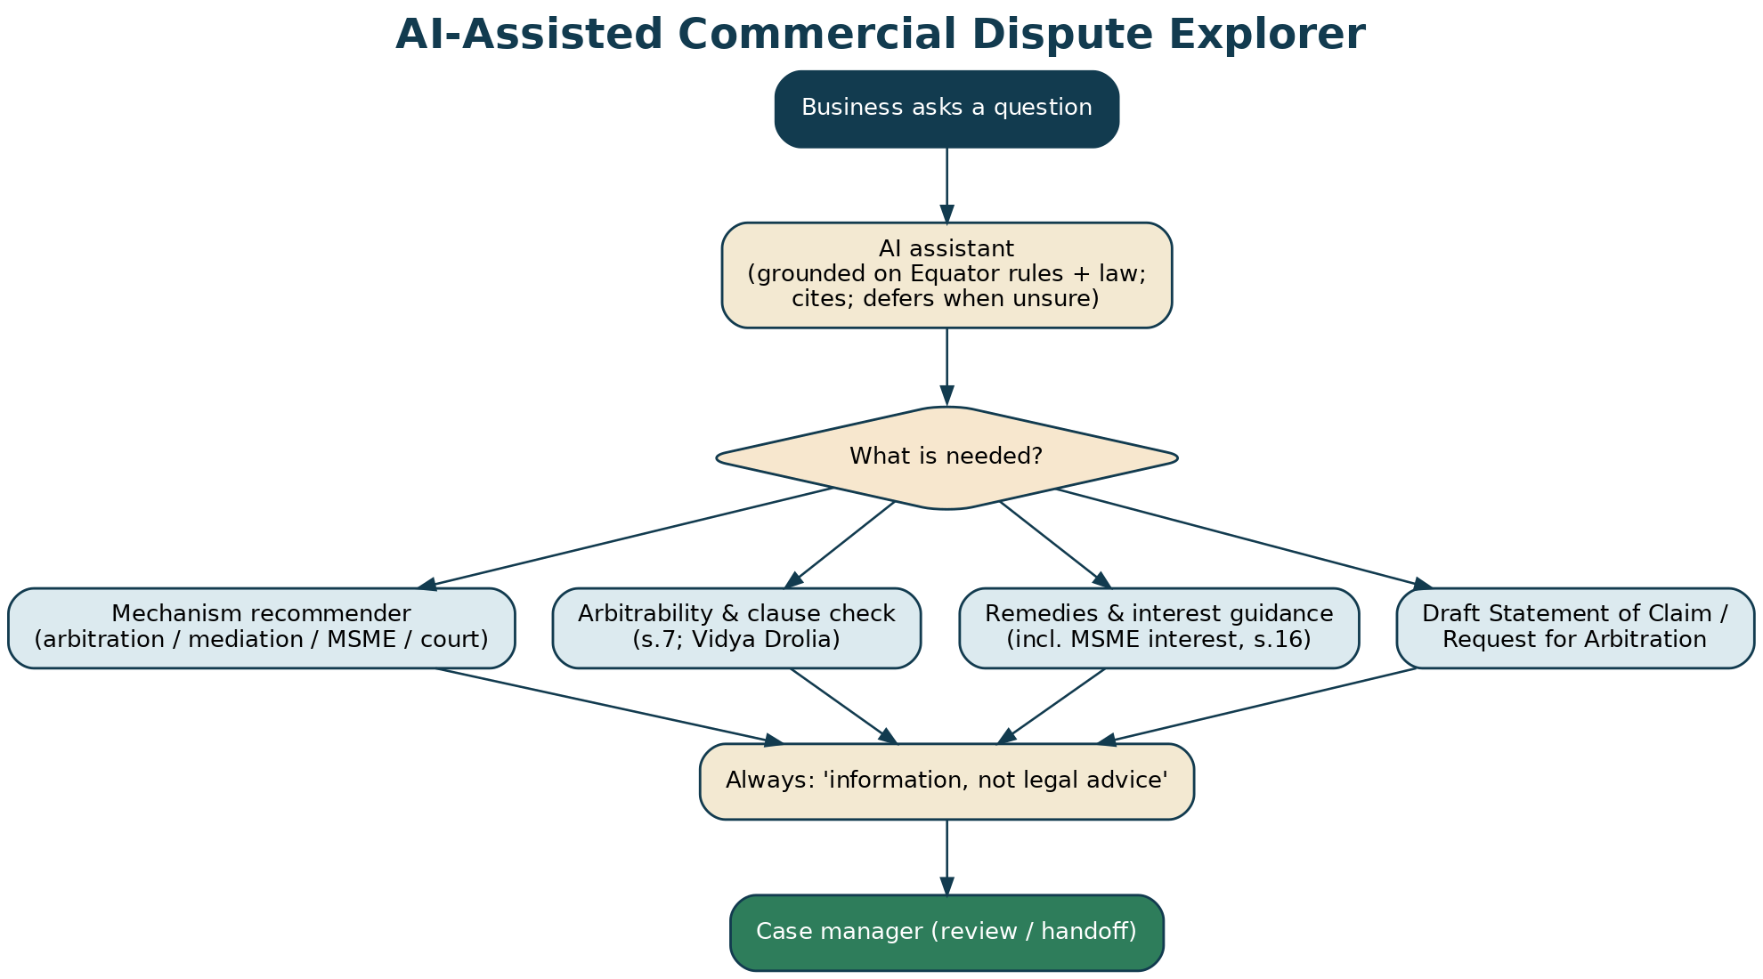
Figure 10 — The AI-assisted commercial Dispute Explorer: mechanism recommender, arbitrability check, drafting.
36. AI Governance, Guardrails & Data Protection
- Information, not legal advice: General legal information and process guidance; directs users to counsel; no unauthorised practice of law.
- Human-in-the-loop: Every draft (request, pleadings, orders, awards) is reviewed and owned by a human.
- Neutrality: The assistant helps both sides equally and never strategises to advantage one party.
- Grounded & cited: Retrieval-augmented over Equator Rules and this Blueprint; refuses/defers rather than guessing.
- Confidential by design: Sits inside the confidentiality ring; a party's private data is never exposed to the other.
- DPDP-compliant: Consent, minimisation, no training on personal/commercial data without consent, audit logs.
- Bias-tested & transparent: Evaluated for fairness; users told when interacting with AI; human always reachable.

RISK / CAUTION
In arbitration the gravest AI risks are compromising tribunal independence and leaking confidential evidence across the confidentiality ring. The AI never decides, never drafts the tribunal's reasoning, and is walled per party — mirroring the tribunal-secretary limits.

37. Online Dispute Resolution (ODR)
Equator is ODR-native: asynchronous exchange of pleadings, evidence and offers; synchronous secure video hearings with document presentation and private breakout rooms; a permissioned case room holding the record, timetable, orders and award with a tamper-evident audit trail; and documents-only and expedited modes. The design follows the UNCITRAL Technical Notes on ODR and India's policy push for ODR, and is ideal for cross-border and multi-city commercial matters.
38. Paperless Filing & e-Signature
Every filing — Request for Arbitration, pleadings, ToR, procedural orders, the award and the MSA — can be completed online and executed with Aadhaar e-Sign or a Digital Signature Certificate, legally valid under the Information Technology Act, 2000 (s.3A and the Second Schedule), with a full audit trail and Section 65B admissibility. Corporate signatories are verified through KYB with board-authority checks.
LEGAL BASIS
IT Act, 2000 — s.3A and Second Schedule (Aadhaar e-Sign); DSC via licensed CAs; s.65B, Bharatiya Sakshya Adhiniyam, 2023 / Indian Evidence Act for admissibility of electronic records; an arbitral award may be signed electronically (s.31 read with the IT Act).

39. On-Platform Execution: e-Stamp & Registration
Settlement agreements and, where applicable, awards are e-stamped on the platform (stamp duty paid digitally via SHCIL), and mediated settlements are registered (Section 20, Mediation Act). The result is an end-to-end digital journey — file, resolve, sign, stamp, enforce — with paper needed only where a specific court or sub-registrar still requires it. Stamp duty being a state subject, per-state availability is confirmed before a state is switched fully paperless.
40. Integration with Courts & Tribunals
Equator interoperates with the judicial and tribunal system in both directions. Referral in: courts refer parties to arbitration under Section 8, appoint arbitrators under Section 11, and refer commercial suits to s.12A mediation and under Section 89 CPC. Court support flows: interim measures under Section 9, and assistance in taking evidence under Section 27. Referral out: Equator delivers the award for enforcement as a decree (Section 36), the MSA for a consent decree, or a certificate of a completed s.12A attempt. Over time, secure e-filing linkage and status sync with court and tribunal systems (aligned with the e-Courts programme) let referrals and outcomes flow with consent.
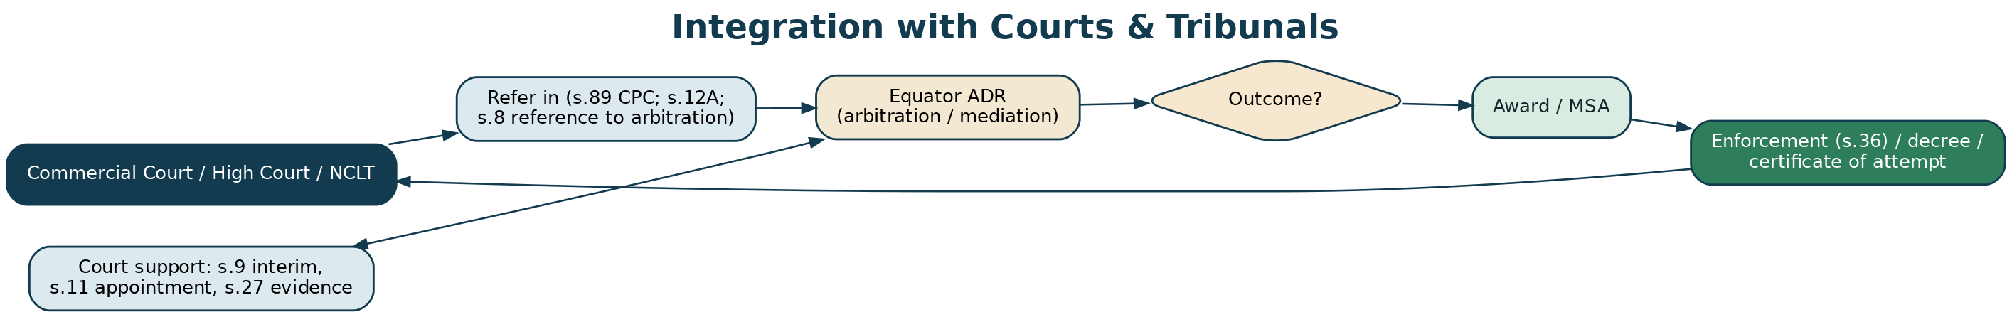
Figure 11 — Two-way integration with commercial courts, High Courts and the NCLT.

PART G
Annexures
Annexure A — Consolidated Legal Authorities
Statutes
Instrument | Relevance
Arbitration & Conciliation Act, 1996 | Arbitration end-to-end: agreement (s.7), reference (s.8), interim (s.9/s.17), appointment (s.11), disclosure (s.12 + Schedules), kompetenz (s.16), pleadings (s.23), timeline (s.29A/29B), award (s.31), set-aside (s.34), enforcement (s.36), foreign awards (Part II)
Draft Arbitration & Conciliation (Amendment) Bill, 2024 | Institutional arbitration; emergency arbitration (s.9A); partial set-aside; appellate arbitration; Arbitration Council of India
Mediation Act, 2023 | Mediation framework; MSA (s.19); registration (s.20); enforceable as decree (s.27)
Commercial Courts Act, 2015 | Mandatory pre-institution mediation (s.12A); specified value; commercial courts
MSMED Act, 2006 | Delayed-payment regime: 45-day payment (s.15), interest (s.16), MSEFC conciliation/arbitration (s.18), 75% pre-deposit (s.19)
Companies Act, 2013 | Oppression & mismanagement (ss.241–242, NCLT); class action (s.245)
Insolvency & Bankruptcy Code, 2016 | Insolvency (non-arbitrable); NCLT jurisdiction
Indian Contract Act 1872; Sale of Goods Act 1930; Specific Relief Act 1963 | Substantive commercial law; escrow basis
IT Act, 2000; DPDP Act, 2023 & Rules 2025 | e-Sign/e-record; data protection
New York Convention (1958); Singapore Convention (2019) | Foreign-award enforcement; cross-border mediated settlements (India signed, not ratified)

Table A-1 — Governing statutes and instruments.
Leading judgments
Case | Proposition
Vidya Drolia v. Durga Trading Corporation, (2021) 2 SCC 1 | Four-fold test for non-arbitrability; prima-facie review at s.8/s.11
M/s Patil Automation v. Rakheja Engineers, (2022) 10 SCC 1 | s.12A pre-institution mediation is mandatory; plaint liable to rejection
Amazon.com NV Investment Holdings v. Future Retail, (2022) 1 SCC 209 | Emergency arbitrator's award enforceable in India-seated arbitration
BALCO v. Kaiser Aluminium, (2012) 9 SCC 552 | Seat of arbitration; Part I/Part II demarcation
BCCI v. Kochi Cricket, (2018) 6 SCC 287 | s.36 — no automatic stay of enforcement on a s.34 challenge
Perkins Eastman v. HSCC, (2020) 20 SCC 760 | A party interested in the outcome cannot unilaterally appoint the sole arbitrator
Cox & Kings v. SAP India, 2023 INSC 1051 | Group-of-companies doctrine — non-signatories may be bound
Booz Allen v. SBI Home Finance, (2011) 5 SCC 532 | Early statement of non-arbitrable categories (rights in rem)

Table A-2 — Leading commercial-arbitration authorities.
RISK / CAUTION
Citations current as of July 2026; verify neutral citations and track the Arbitration Amendment Bill, 2024 and Arbitration Council of India developments before filing.

Annexure B — Dispute Taxonomy Matrix
The complete Dispute-type → issue → mechanism → applicable-law → relief → forms → arbitrability matrix is delivered in the Developer Workbook (sheet: 'Dispute Taxonomy'); Table 2 is the abbreviated view.
Annexure C — Glossary
Term | Meaning
Seat / venue | The legal home of the arbitration (seat) vs the physical location of hearings (venue)
Kompetenz-kompetenz | The tribunal's power to rule on its own jurisdiction (s.16)
ToR / PO-1 | Terms of Reference / Procedural Order No. 1 — the case's scope and timetable
Consent award | An award recording a settlement reached during arbitration (s.30)
Emergency arbitrator | A neutral who grants urgent relief before the main tribunal is constituted
Ad valorem | Fees scaled to the amount in dispute
Section 12A | Mandatory pre-institution mediation for commercial suits
MSEFC / Samadhaan | MSE Facilitation Council / the MSME delayed-payment portal
Set-aside (s.34) | Application to annul an award on limited grounds
New York Convention | Treaty for enforcement of foreign arbitral awards

Table C-1 — Glossary.
Annexure D — Companion Deliverables
- Forms (Part H): 20 commercial forms (F-C01–F-C20) in Part H and as standalone documents in the archive.
- Developer Workbook: dropdowns, taxonomy, form schemas, neutral filters, workflow states, SLAs, API, integrations, PII map, AI features, KPIs — with live data-validation.
- Diagram set: 10 diagrams (arbitration lifecycle, s.12A, MSME, arbitrability, appointment, enforcement, escrow, AI, court integration, timeline) as PNG + SVG.
- Calculators: claim-value fee estimator and MSME delayed-payment interest calculator.
- Board deck, toolkit, compliance & outreach: as per the family package, adapted for commercial.

Annexure E — Model Clause Library
Ready-to-adapt clauses for commercial contracts and settlements. Drafting aids — tailor and have counsel settle before use. Bracketed items […] to be completed.
CLAUSE 1 — EQUATOR ARBITRATION CLAUSE (for contracts)
Any dispute arising out of or in connection with this contract, including its existence, validity or termination, shall be referred to and finally resolved by arbitration administered by Equator Resolution under the Equator Rules of Arbitration in force at the date of the notice of arbitration, which Rules are deemed incorporated. The seat of arbitration shall be [city], the language [English], and the tribunal shall consist of [a sole arbitrator / three arbitrators]. The governing law of the contract is [Indian law].

CLAUSE 2 — TIERED (MED-ARB) CLAUSE
The parties shall first attempt in good faith to resolve any dispute by negotiation between senior management within [15] days, then by mediation administered by Equator Resolution under its Mediation Rules within [30] days; any dispute not so resolved shall be finally resolved by arbitration under the Equator Rules of Arbitration (as in Clause 1).

CLAUSE 3 — EXPEDITED / EMERGENCY RELIEF
Where the amount in dispute does not exceed ₹[…], the Expedited Procedure of the Equator Rules shall apply. A party requiring urgent interim relief before the tribunal is constituted may apply for an emergency arbitrator under those Rules, without prejudice to any application under Section 9 of the Arbitration & Conciliation Act, 1996.

CLAUSE 4 — MSME REFERENCE
Nothing in this contract limits a micro or small enterprise supplier's statutory right to refer a delayed-payment dispute to the Micro & Small Enterprises Facilitation Council under Section 18 of the MSMED Act, 2006.

CLAUSE 5 — ESCROW OF AWARD / SETTLEMENT SUMS
Sums payable under any award or settlement shall be deposited into the Equator escrow account with […] Bank and released to the payee on [lapse of the Section 34 period without a stay / delivery / the agreed milestone], per the escrow instruction (Form F-C15).

CLAUSE 6 — CONFIDENTIALITY
The arbitration/mediation, all submissions, evidence and the award/settlement shall be kept confidential by the parties, the neutral and Equator, save as required for enforcement or by law.

CLAUSE 7 — CONSENT AWARD ON SETTLEMENT
If the parties settle during the arbitration, they may request the tribunal to record the settlement as an arbitral award on agreed terms under Section 30 of the Arbitration & Conciliation Act, 1996.

RISK / CAUTION
Templates, not advice. Seat, governing law, number of arbitrators, and arbitrability must be settled by counsel for the specific contract; a defective clause can derail enforcement.

PART H
The Forms (Full Text)
This Part reproduces every Equator commercial form in full (F-C01 to F-C20), ready to lift into the platform or use directly. The same set is delivered as individual documents in the archived Forms Pack folder. Fields shown blank are for completion by the party, neutral or case manager as indicated.

Onboarding, KYB / KYC & Data-Protection Consent | Form F-C01
Create your account, verify your business, and record DPDP consent.
A. PARTY / BUSINESS DETAILS (KYB)

Party name (entity / individual)
Type (Pvt Ltd / LLP / Partnership / Proprietor / Individual)
CIN / LLPIN / Registration no.
GSTIN / PAN
Registered / principal address
Authorised signatory & designation
Authority (board resolution / PoA reference)
Contact person
Mobile
Email
Counsel / representative (if any)

Specimen: Acme Components Pvt Ltd · CIN U12345MH2015PTC000000 · GSTIN 27ABCDE1234F1Z5 · signatory: Director, authorised by board resolution dated __.

B. ROLE

Role:
☐ Claimant / Applicant | ☐ Respondent

C. DATA-PROTECTION NOTICE & CONSENT (DPDP Act, 2023)

Your data is processed only to administer the dispute (case management, appointment, hearings, escrow, enforcement) and for statutory compliance. Commercially sensitive data is kept confidential with need-to-know access.
DECLARATION & UNDERTAKING

☐ I give free, specific, informed and withdrawable consent to processing our data for these purposes.
☐ I am authorised to represent and bind the above entity.
☐ The information provided is true and correct.

________________________  Authorised signatory  Name / Signature / Date | ________________________  Verified by (Equator)  Name / Signature / Date

Grievance / Data Officer: grievance@equatorresolution.com. Equator acts as a Data Fiduciary under the DPDP Act, 2023.

Request for Arbitration | Form F-C02
Commences an arbitration under an arbitration agreement (s.7). Filed by the Claimant.
Case No. (Equator)
Date

1. PARTIES

Party name (entity / individual)
Type (Pvt Ltd / LLP / Partnership / Proprietor / Individual)
CIN / LLPIN / Registration no.
GSTIN / PAN
Registered / principal address
Authorised signatory & designation
Authority (board resolution / PoA reference)
Contact person
Mobile
Email
Counsel / representative (if any)

2. THE ARBITRATION AGREEMENT

Contract & date
Arbitration clause (number / text reference)
Seat & venue
Governing law
Language
Number of arbitrators (sole / three)

3. NATURE OF THE DISPUTE

Dispute type(s):
☐ Breach of contract / damages | ☐ Payment & recovery
☐ Supply / vendor / procurement | ☐ Distribution / franchise / agency
☐ Shareholder / JV / partnership | ☐ Construction & infrastructure
☐ Technology / IT / IP | ☐ Real estate & lease
☐ Banking / finance / guarantee | ☐ MSME delayed payment
☐ Company oppression / mismanagement | ☐ Cross-border / international
☐ Other

Sector:
☐ Manufacturing | ☐ IT / technology
☐ Construction / infrastructure | ☐ BFSI / finance
☐ Real estate | ☐ Pharma / healthcare
☐ Retail / FMCG | ☐ Energy
☐ Logistics | ☐ Professional services
☐ Other

Amount in dispute (₹)
Brief summary of the dispute

Brief statement of facts & claims

4. RELIEF CLAIMED

Relief:
☐ Damages / compensation | ☐ Debt / price recovery + interest
☐ Specific performance | ☐ Injunction
☐ Declaration | ☐ Account / audit
☐ Termination / restitution | ☐ Return of goods / property
☐ Costs | ☐ Escrow-secured payment
☐ Other

5. NOMINATION

Claimant's nominee arbitrator (if three-member)
Proposed sole arbitrator (if agreed)

DECLARATION & UNDERTAKING

☐ We invoke the arbitration agreement and request Equator to administer the arbitration under its Rules.
☐ We agree to pay the fees under the Equator schedule.
☐ The information is true to the best of our knowledge.

________________________  Claimant / Counsel  Name / Signature / Date | ________________________  Received by (Equator)  Name / Signature / Date

Response to Request for Arbitration (with Counterclaim) | Form F-C03
The Respondent's reply, including any jurisdictional objection and counterclaim (s.23).
Case No.
Responding to RFA dated

1. RESPONDENT DETAILS

Party name (entity / individual)
Type (Pvt Ltd / LLP / Partnership / Proprietor / Individual)
CIN / LLPIN / Registration no.
GSTIN / PAN
Registered / principal address
Authorised signatory & designation
Authority (board resolution / PoA reference)
Contact person
Mobile
Email
Counsel / representative (if any)

2. POSITION

We:
☐ Accept the arbitration and Equator's administration
☐ Object to jurisdiction / arbitrability (state grounds below)
☐ Accept, but dispute the claim

Response to the claim / jurisdictional objection

3. COUNTERCLAIM (if any)

Counterclaim type(s):
☐ Breach of contract / damages | ☐ Payment & recovery
☐ Supply / vendor / procurement | ☐ Distribution / franchise / agency
☐ Shareholder / JV / partnership | ☐ Construction & infrastructure
☐ Technology / IT / IP | ☐ Real estate & lease
☐ Banking / finance / guarantee | ☐ MSME delayed payment
☐ Company oppression / mismanagement | ☐ Cross-border / international
☐ Other

Amount counterclaimed (₹)

Counterclaim — facts & relief

4. NOMINATION

Respondent's nominee arbitrator (if three-member)

DECLARATION & UNDERTAKING

☐ The contents are true to the best of our knowledge and belief.

________________________  Respondent / Counsel  Name / Signature / Date | ________________________  Received by (Equator)  Name / Signature / Date

Request for Mediation / s.12A Pre-Institution Mediation Application | Form F-C04
Commences commercial mediation — voluntary, or the mandatory pre-institution route (Commercial Courts Act, s.12A).
Case No.
Date

1. PARTIES

Party name (entity / individual)
Type (Pvt Ltd / LLP / Partnership / Proprietor / Individual)
CIN / LLPIN / Registration no.
GSTIN / PAN
Registered / principal address
Authorised signatory & designation
Authority (board resolution / PoA reference)
Contact person
Mobile
Email
Counsel / representative (if any)

2. THE DISPUTE

Route:
☐ Voluntary commercial mediation
☐ Mandatory pre-institution mediation (s.12A) before a commercial suit

Dispute type(s):
☐ Breach of contract / damages | ☐ Payment & recovery
☐ Supply / vendor / procurement | ☐ Distribution / franchise / agency
☐ Shareholder / JV / partnership | ☐ Construction & infrastructure
☐ Technology / IT / IP | ☐ Real estate & lease
☐ Banking / finance / guarantee | ☐ MSME delayed payment
☐ Company oppression / mismanagement | ☐ Cross-border / international
☐ Other

Specified value / amount (₹)
Is urgent interim relief contemplated? (Y/N)

Brief summary of the dispute & relief sought

3. OTHER PARTY

Name & contact of the opposite party

DECLARATION & UNDERTAKING

☐ We authorise Equator to administer the mediation and to notify the other party.
☐ We understand an MSA, once signed & registered, is enforceable as a decree (s.27).

________________________  Applicant / Counsel  Name / Signature / Date | ________________________  Received by (Equator)  Name / Signature / Date

For s.12A: a commercial suit of specified value not contemplating urgent interim relief must attempt this mediation before filing (Patil Automation).

Nomination & Appointment of Arbitrator | Form F-C05
Records the parties' nomination(s) and Equator's appointment / confirmation of the tribunal.
Case No.
Sole or three-member
Claimant's nominee
Respondent's nominee
Presiding / sole arbitrator
Method (party / institutional / s.11)

Every appointee must file the Disclosure & Statement of Independence (F-C06) and clear the Fifth & Seventh Schedule checks before confirmation.

________________________  Claimant  Name / Signature / Date | ________________________  Respondent  Name / Signature / Date | ________________________  Equator (appointing authority)  Name / Signature / Date

Arbitrator's Disclosure & Statement of Independence (s.12) | Form F-C06
Mandatory disclosure under Section 12 and the Fifth & Seventh Schedules.
Case No.
Arbitrator
Panel ID / grade

DECLARATION

DECLARATION & UNDERTAKING

☐ I am independent and impartial and have no relationship with the parties, counsel or subject-matter that falls within the Seventh Schedule (ineligibility).
☐ I disclose below any circumstance under the Fifth Schedule that may give rise to justifiable doubts.
☐ I have sufficient time to complete the arbitration within the Section 29A timeline.
☐ I will disclose any such circumstance arising later, without delay.

DISCLOSURES (if any)

Circumstance disclosed

________________________  Arbitrator  Name / Signature / Date | ________________________  Equator  Name / Signature / Date

Terms of Reference | Form F-C07
Defines the scope of the arbitration — parties, claims, issues, seat, law and procedure.
Case No.
Tribunal
Seat / venue
Governing law
Language

SUMMARY OF CLAIMS & COUNTERCLAIMS

Party | Claim / counterclaim (summary) | Amount (₹)

ISSUES FOR DETERMINATION

No. | Issue

________________________  Claimant  Name / Signature / Date | ________________________  Respondent  Name / Signature / Date | ________________________  Tribunal  Name / Signature / Date

Procedural Order No. 1 | Form F-C08
The procedural timetable and case-management directions.
Case No.
Date of first procedural hearing

TIMETABLE & DIRECTIONS

Step | Direction / date

Mode of hearings (in-person / video / hybrid)
Document-production protocol
Section 29A clock — pleadings complete by
Confidentiality directions

________________________
Tribunal
Name / Signature / Date

Statement of Claim | Form F-C09
The Claimant's full case (s.23). May be AI-assisted; review and have counsel settle.
Case No.
Claimant
Respondent

1. FACTS (numbered, chronological)

No. | Fact

2. THE CONTRACT & BREACH

Term relied upon | Breach alleged

3. ISSUES & RELIEF

Relief:
☐ Damages / compensation | ☐ Debt / price recovery + interest
☐ Specific performance | ☐ Injunction
☐ Declaration | ☐ Account / audit
☐ Termination / restitution | ☐ Return of goods / property
☐ Costs | ☐ Escrow-secured payment
☐ Other

Amount claimed (₹)
Interest claimed (rate / basis)

Prayer

4. EVIDENCE / DOCUMENTS

Document | Exhibit no.

May be prepared with AI assistance from your account & contract — a draft for your review, not legal advice.

DECLARATION & UNDERTAKING

☐ The facts are true to the best of our knowledge and belief.

________________________
Claimant / Counsel
Name / Signature / Date

Statement of Defence & Counterclaim | Form F-C10
The Respondent's full reply and any counterclaim (s.23).
Case No.
Respondent

1. RESPONSE TO THE CLAIM (para-by-para)

Claim para | Admit / Deny | Response

2. RESPONDENT'S CASE / ADDITIONAL FACTS

No. | Fact

3. COUNTERCLAIM & RELIEF

Relief:
☐ Damages / compensation | ☐ Debt / price recovery + interest
☐ Specific performance | ☐ Injunction
☐ Declaration | ☐ Account / audit
☐ Termination / restitution | ☐ Return of goods / property
☐ Costs | ☐ Escrow-secured payment
☐ Other

Counterclaim — facts & prayer

DECLARATION & UNDERTAKING

☐ The contents are true to the best of our knowledge and belief.

________________________
Respondent / Counsel
Name / Signature / Date

Application for Interim Measures | Form F-C11
For urgent relief — from the tribunal (s.17), the court (s.9), or an emergency arbitrator.
Case No.
Applicant
Forum (Tribunal s.17 / Court s.9 / Emergency arbitrator)

RELIEF SOUGHT

Interim relief:
☐ Preserve / secure the amount in dispute
☐ Injunction (restrain / mandatory)
☐ Preserve or detain property / goods
☐ Restrain a call on a guarantee
☐ Appointment of receiver
☐ Other

Grounds — urgency, prima facie case, balance of convenience, irreparable harm

DECLARATION & UNDERTAKING

☐ We undertake as to damages and to comply with any conditions imposed.

________________________
Applicant / Counsel
Name / Signature / Date

Consent Award / Mediated Settlement Agreement | Form F-C12
Records a settlement — as a consent award (s.30) in arbitration, or an MSA (Mediation Act) in mediation.
Case No.
Date & place
Party 1
Party 2
Neutral

RECITALS

The parties have, of their own free will, settled the dispute described in the case file on the terms below.
AGREED TERMS

1. Amount payable & schedule (₹)
2. Interest / costs
3. Performance obligations & timelines
4. Return of goods / property / documents
5. Confidentiality & non-disparagement
6. Escrow (see F-C15)
7. Full & final settlement of

EXECUTION & ENFORCEABILITY

In arbitration, the tribunal records this as an arbitral award on agreed terms (s.30), enforceable as a decree (s.36). In mediation, this MSA is registered (s.20) and enforceable as a decree (s.27).
Stamp duty / e-stamp certificate no.
Registration / authority & date

________________________  Party 1  Name / Signature / Date | ________________________  Party 2  Name / Signature / Date | ________________________  Neutral (authenticating)  Name / Signature / Date

Application for Time Extension (s.29A) | Form F-C13
To extend the mandate/timeline for the award by consent.
Case No.
Pleadings completed on
Current s.29A expiry
Extension sought (months, max 6)
New target

REASON

Reason

DECLARATION & UNDERTAKING

☐ The parties consent to extend the tribunal's mandate under s.29A by the period stated (max 6 months).

________________________  Claimant  Name / Signature / Date | ________________________  Respondent  Name / Signature / Date | ________________________  Tribunal  Name / Signature / Date

MSME Samadhaan Reference | Form F-C14
For a micro/small supplier to refer a delayed-payment dispute to the MSE Facilitation Council (s.18).
Supplier (MSE) name & Udyam Registration no.
Buyer name & details
Invoice no(s). & date(s)
Amount due (₹)
Date of acceptance / deemed acceptance
Due date (within 45 days, s.15)
Days overdue
Interest claimed (3x bank rate, compounded — s.16)

PARTICULARS OF THE CLAIM

Description of goods/services supplied & the default

DECLARATION & UNDERTAKING

☐ We refer this delayed-payment dispute to the MSE Facilitation Council for conciliation and, failing settlement, arbitration under s.18 of the MSMED Act, 2006.
☐ The particulars are true and correct.

________________________
Supplier (authorised signatory)
Name / Signature / Date

Use the MSME interest calculator (companion tool) to compute interest at three times the RBI bank rate, compounded monthly.

Escrow Instruction & Release Schedule | Form F-C15
Secures award/settlement money with a regulated escrow agent, released against conditions.
Case No.
Payer
Payee
Escrow agent / bank
Total amount (₹)
Source of funds (KYC/PMLA verified)

RELEASE SCHEDULE

Tranche | Amount (₹) | Release trigger / milestone | Evidence required

Typical triggers: lapse of the s.34 window without a stay; delivery / handover; completion of a performance step.
Fallback if milestone not met by (date)
Escrow fees & bearer

DECLARATION & UNDERTAKING

☐ The payer irrevocably deposits the sum to be released only on the stated conditions.
☐ Both parties consent to the escrow agent acting on these instructions, and to KYC/PMLA compliance.

________________________  Payer  Name / Signature / Date | ________________________  Payee  Name / Signature / Date | ________________________  Escrow Officer (Equator)  Name / Signature / Date

Enforcement Checklist | Form F-C16
Steps to enforce an award or settlement.
Case No.
Outcome (award / consent award / MSA)

CHECKLIST

Confirm:
☐ s.34 challenge window elapsed / challenge failed (domestic award)
☐ Award signed, stamped & delivered to parties (s.31)
☐ For foreign award: New York Convention documents (s.47) ready
☐ For MSA: registered (s.20)
☐ Stamp duty paid / e-stamped
☐ Certified copy obtained
☐ Enforcement petition prepared (s.36 / Part II)
☐ Escrow release conditions verified

________________________
Case Manager (Equator)
Name / Signature / Date

Case Closure / Award Transmittal | Form F-C17
Transmits the award/outcome and closes the file.
Case No.
Parties
Neutral
Outcome
Date of award / settlement
Date of closure

Result:
☐ Award rendered
☐ Consent award (settled)
☐ Mediated settlement (MSA)
☐ Withdrawn
☐ Non-settlement (mediation) / report issued

Summary (no confidential deliberation disclosed)
Enforcement / next steps

________________________  Neutral  Name / Signature / Date | ________________________  Case Manager (Equator)  Name / Signature / Date

Agreement to Mediate & Confidentiality (Commercial) | Form F-C18
Signed before the first mediation session.
Case No.
Party 1
Party 2
Mediator

1. The parties appoint the mediator, through Equator as MSP, to mediate the commercial dispute under the Mediation Act, 2023.
2. Participation is voluntary; either party or the mediator may terminate at any time.
3. All communications are confidential and without prejudice and shall not be used in any court or arbitration, save as the law requires.
4. The mediator is neutral, gives no legal advice, and does not decide the dispute.
DECLARATION & UNDERTAKING

☐ We agree to the terms above and will participate in good faith.
☐ We understand a signed, registered MSA is enforceable as a decree.

________________________  Party 1  Name / Signature / Date | ________________________  Party 2  Name / Signature / Date | ________________________  Mediator  Name / Signature / Date

Costs & Fee Statement | Form F-C19
Records fees and costs payable.
Invoice / statement no.
Date
Case No.
Amount in dispute (₹)

PARTICULARS

Particulars | Basis | Amount (₹)

Administration fee (ad valorem) (₹)
Neutral fee (₹)
Escrow / misc. (₹)
Taxes (GST) (₹)
Total (₹)

Arbitrator fees may follow the Fourth Schedule to the Arbitration Act or the Equator schedule; see the fee calculator.

________________________
Authorised signatory (Equator)
Name / Signature / Date

Model Arbitration & ADR Clause (for contracts) | Form F-C20
Drop-in clause to name Equator in your commercial contracts (see Annexure E for variants).
RECOMMENDED CLAUSE

“Any dispute arising out of or in connection with this contract, including its existence, validity or termination, shall be referred to and finally resolved by arbitration administered by Equator Resolution under the Equator Rules of Arbitration, which Rules are deemed incorporated. The seat shall be [city], the language [English], and the tribunal shall consist of [a sole arbitrator / three arbitrators]. The parties shall first attempt mediation under the Equator Mediation Rules. The governing law is [Indian law].”
COMPLETE THE VARIABLES

Seat / venue
Language
Number of arbitrators
Governing law
Tiered (med-arb)? (Y/N)

Confirm arbitrability and seat with counsel. For MSME supplies, the statutory s.18 route remains available regardless of this clause.

